**Assignment 5: MySQL and Cloud Spanner in GCP**

**Pre-requisites:**

* Make sure you have a Gmail account and access to GCP

**Assignment 1: MySQL**

Go to GCP project home page, navigate to marketplace, enable Cloud SQL Admin API

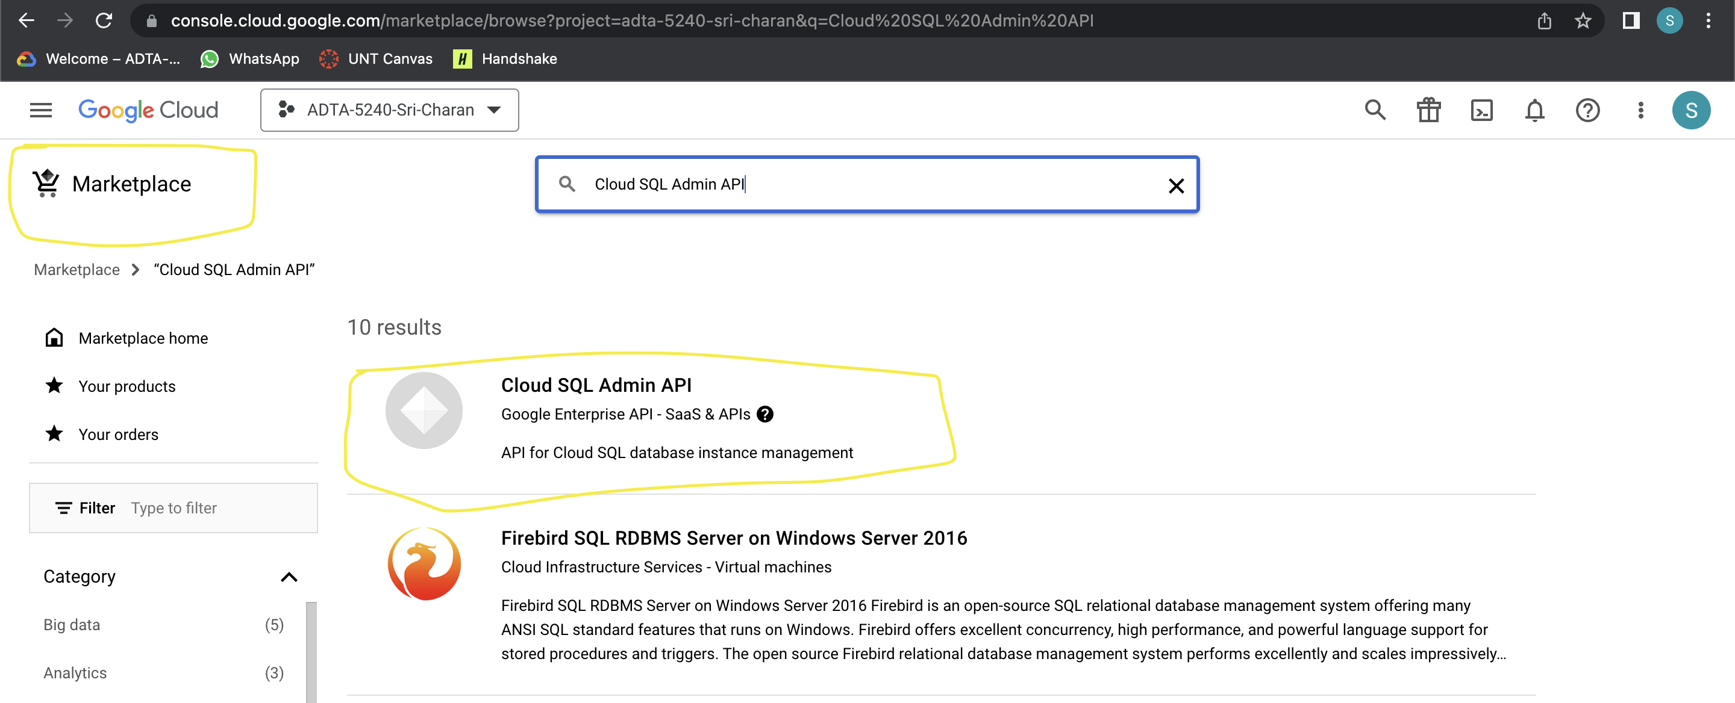

**Task 1: Create MySQL Instance**

*Every time you create new SQL Database, you are first asked to create MySQL instance which allocates resources like VM, memory etc.*

1. Click on the 3-line icon button at top-left corner of the screen, a dock opens. Scroll to the “SQL” option and click on it

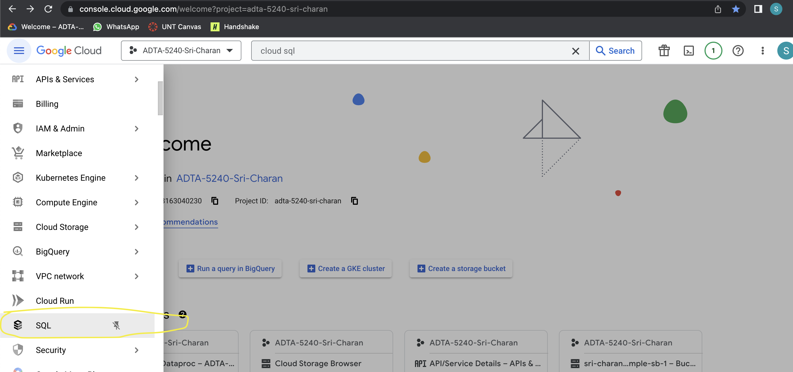

1. Now, click on create instance and click on “choose MySQL”

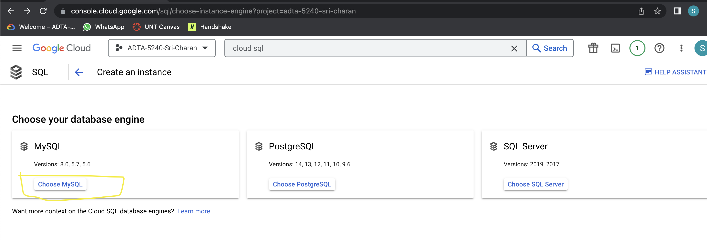

1. Give name to the MySQL instance( I gave as mysql-instance-by-11661666), generate password and make sure you remember it and keep other values as is. Then click “Create Instance”

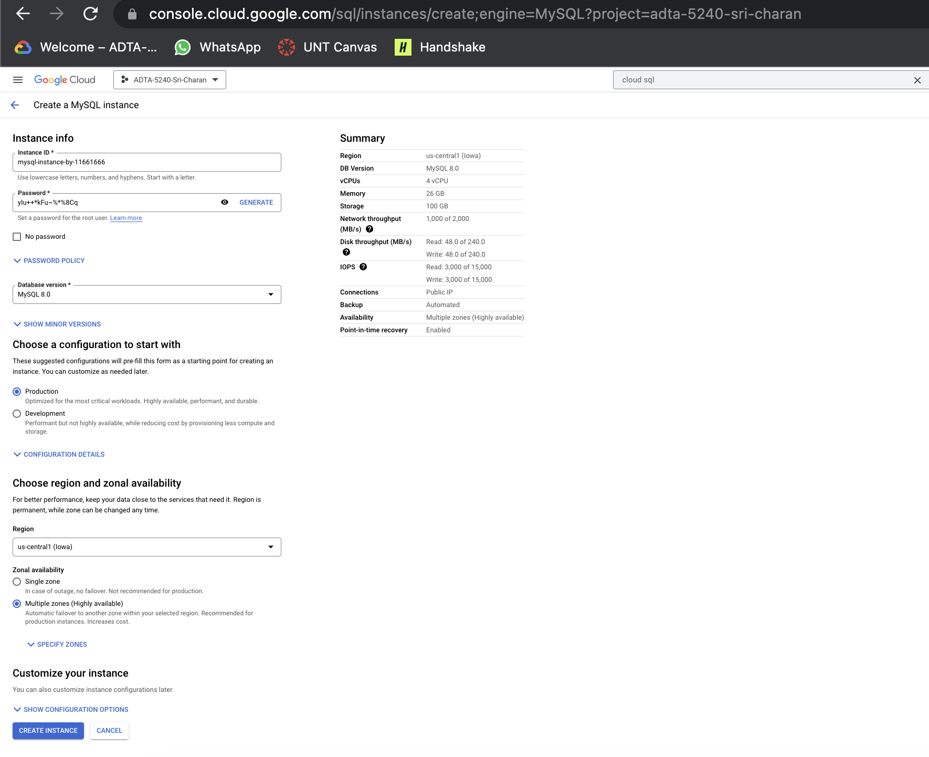

1. Hang on! it takes a moment to initialize the components in MySQL. You should see green tick mark beside the instance once instance is up and running

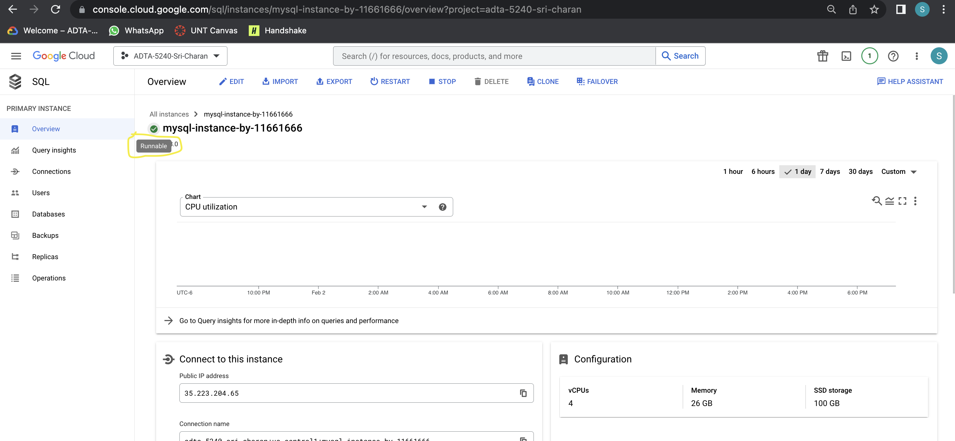

**Instance Name**: mysql-instance-by-11661666

**Task 2: Create Database, Table, load data into table and show data from table using line commands**

1. Under the newly created instance(mysql-instance-by-11661666) page go to the section named “Connect to this instance” and select section “OPEN CLOUD SHELL”. Click continue on dialog box and please wait a moment to load the cloud shell

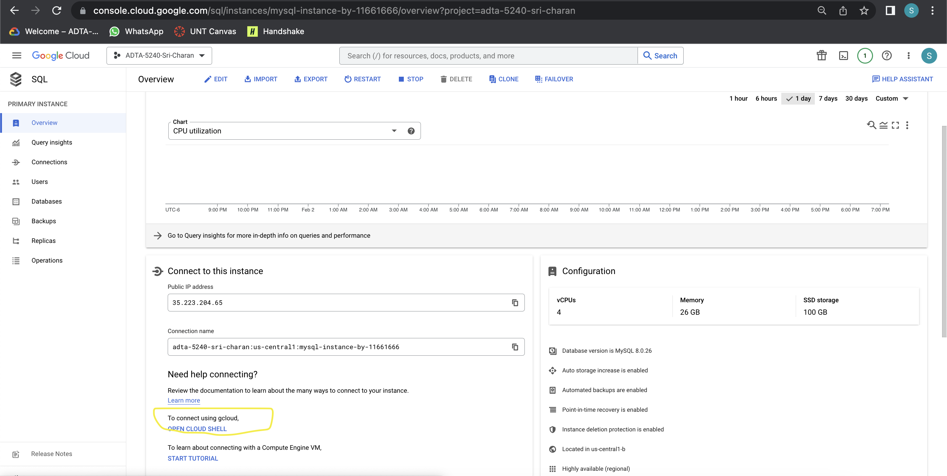

1. After it loads, you can see cloud shell at bottom of your screen

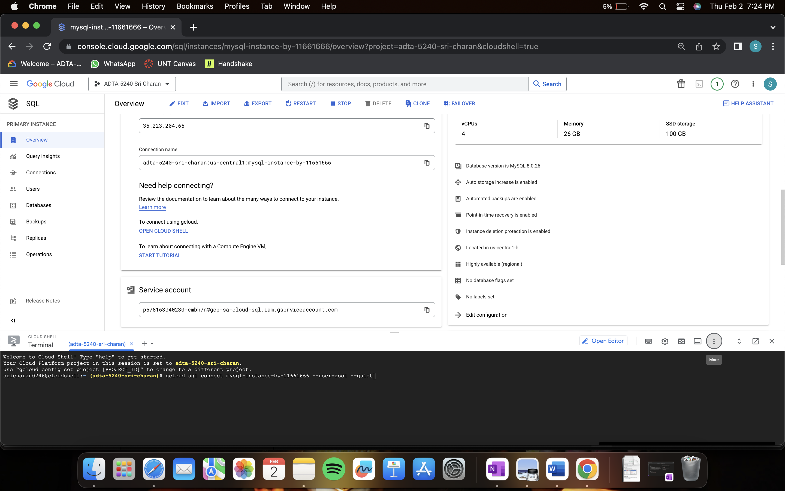

1. Now, run below command to connect created instance via cloud shell
2. gcloud sql connect mysql-instance-by-11661666 -user=root

1. then enter password manually
2. you can open cloud shell in new browser tab
3. once, you enter credentials correctly, you can login into database instance

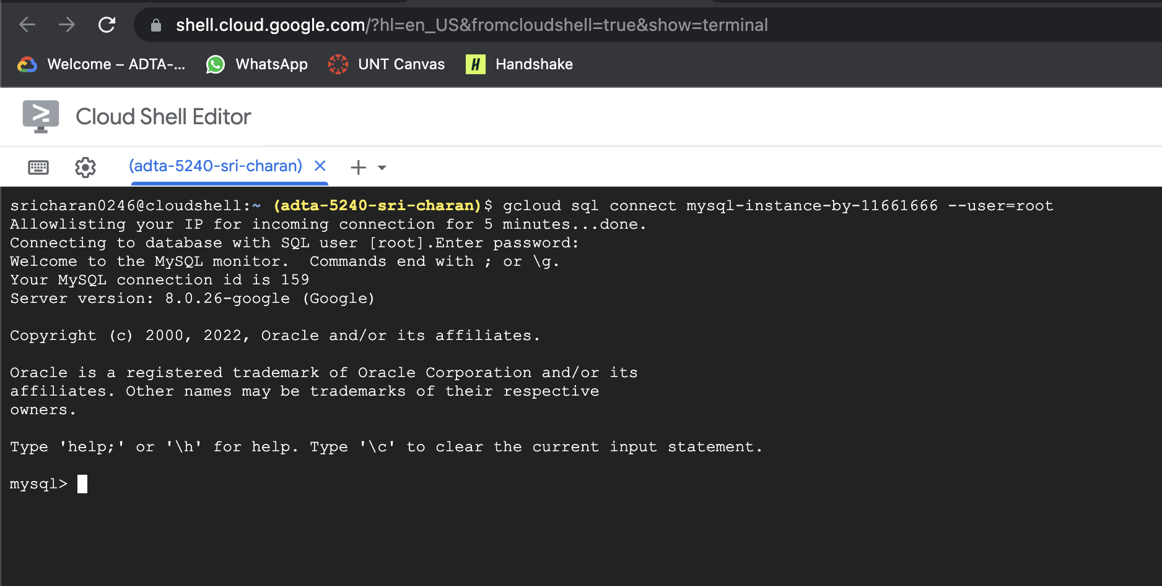

1. Now, you can create new database by entering following command
   1. CREATE DATABASE students;

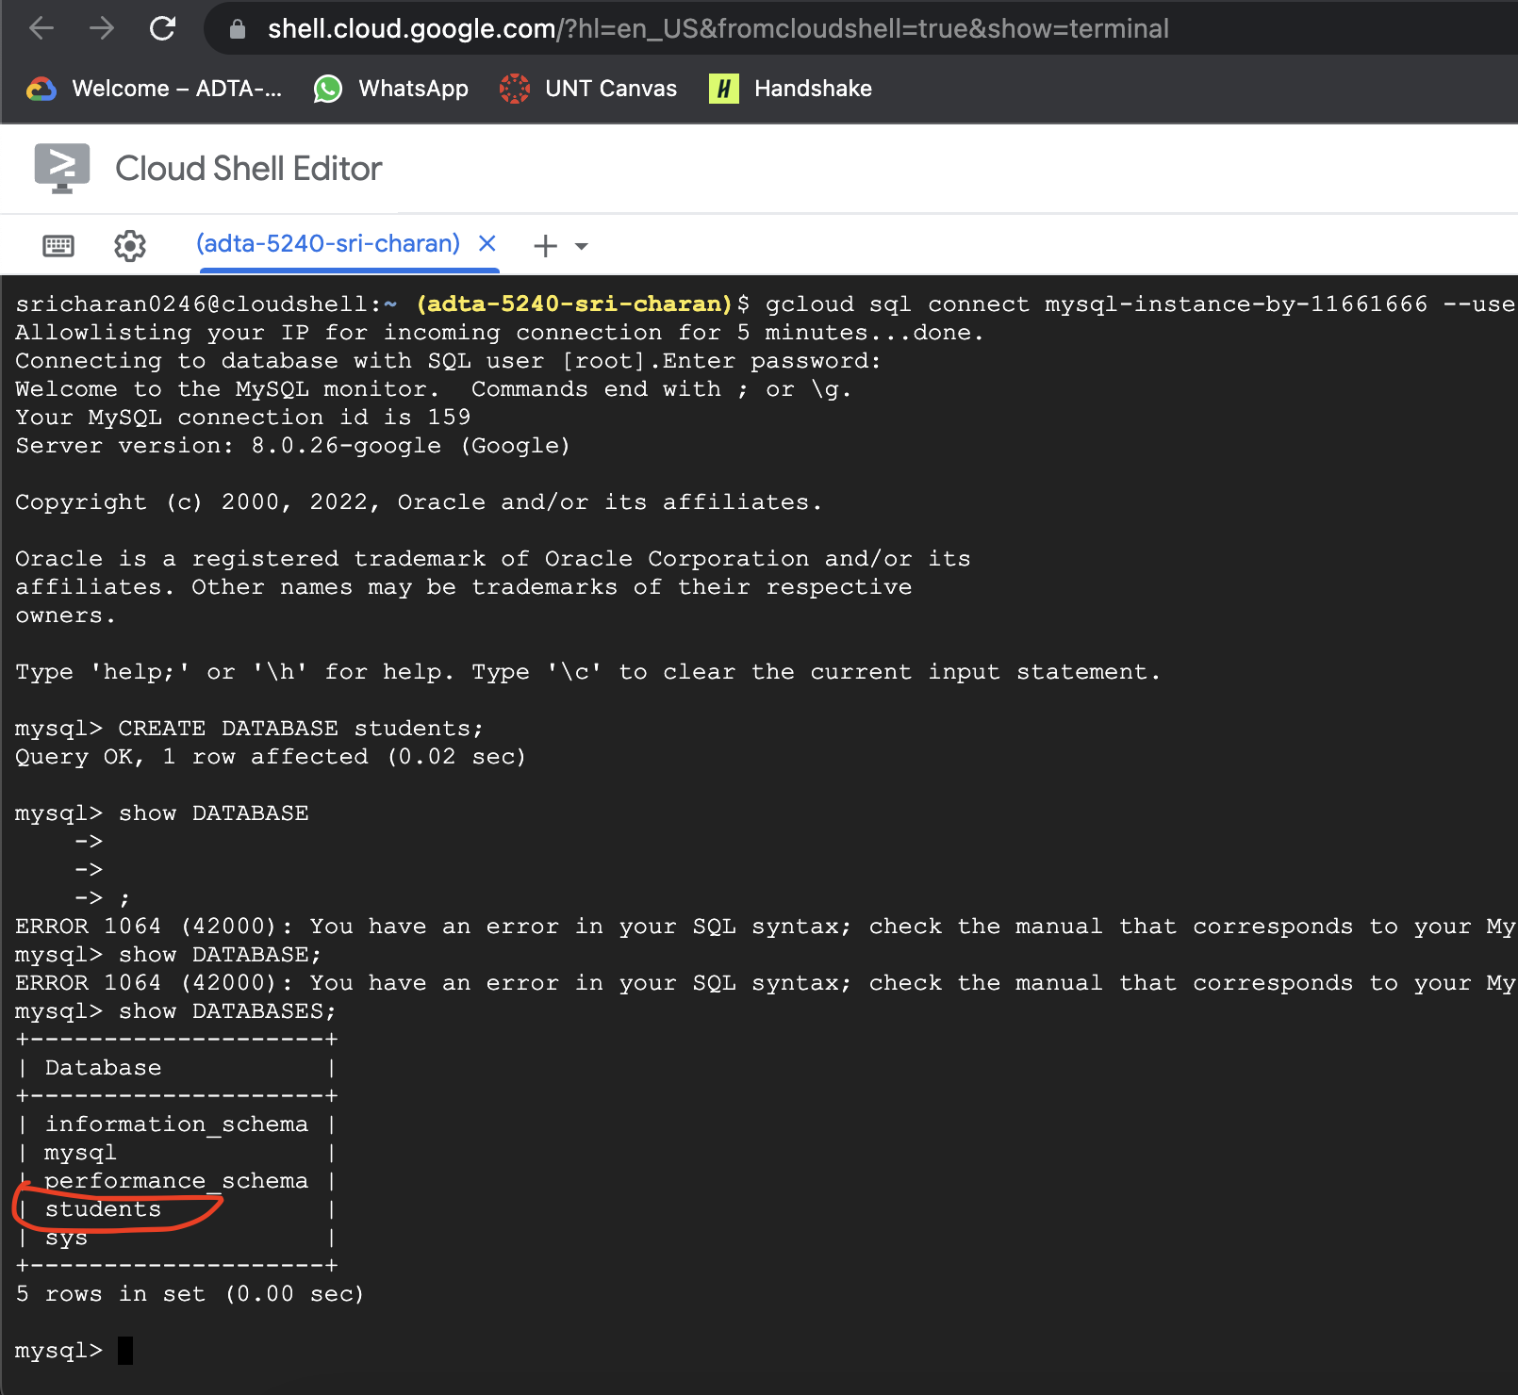

1. Create new table under students database by entering following commands sequentially
   1. USE students;
   2. CREATE TABLE students(sId VARCHAR(255), fName VARCHAR(255), lName VARCHAR(255), phone VARCHAR(255));

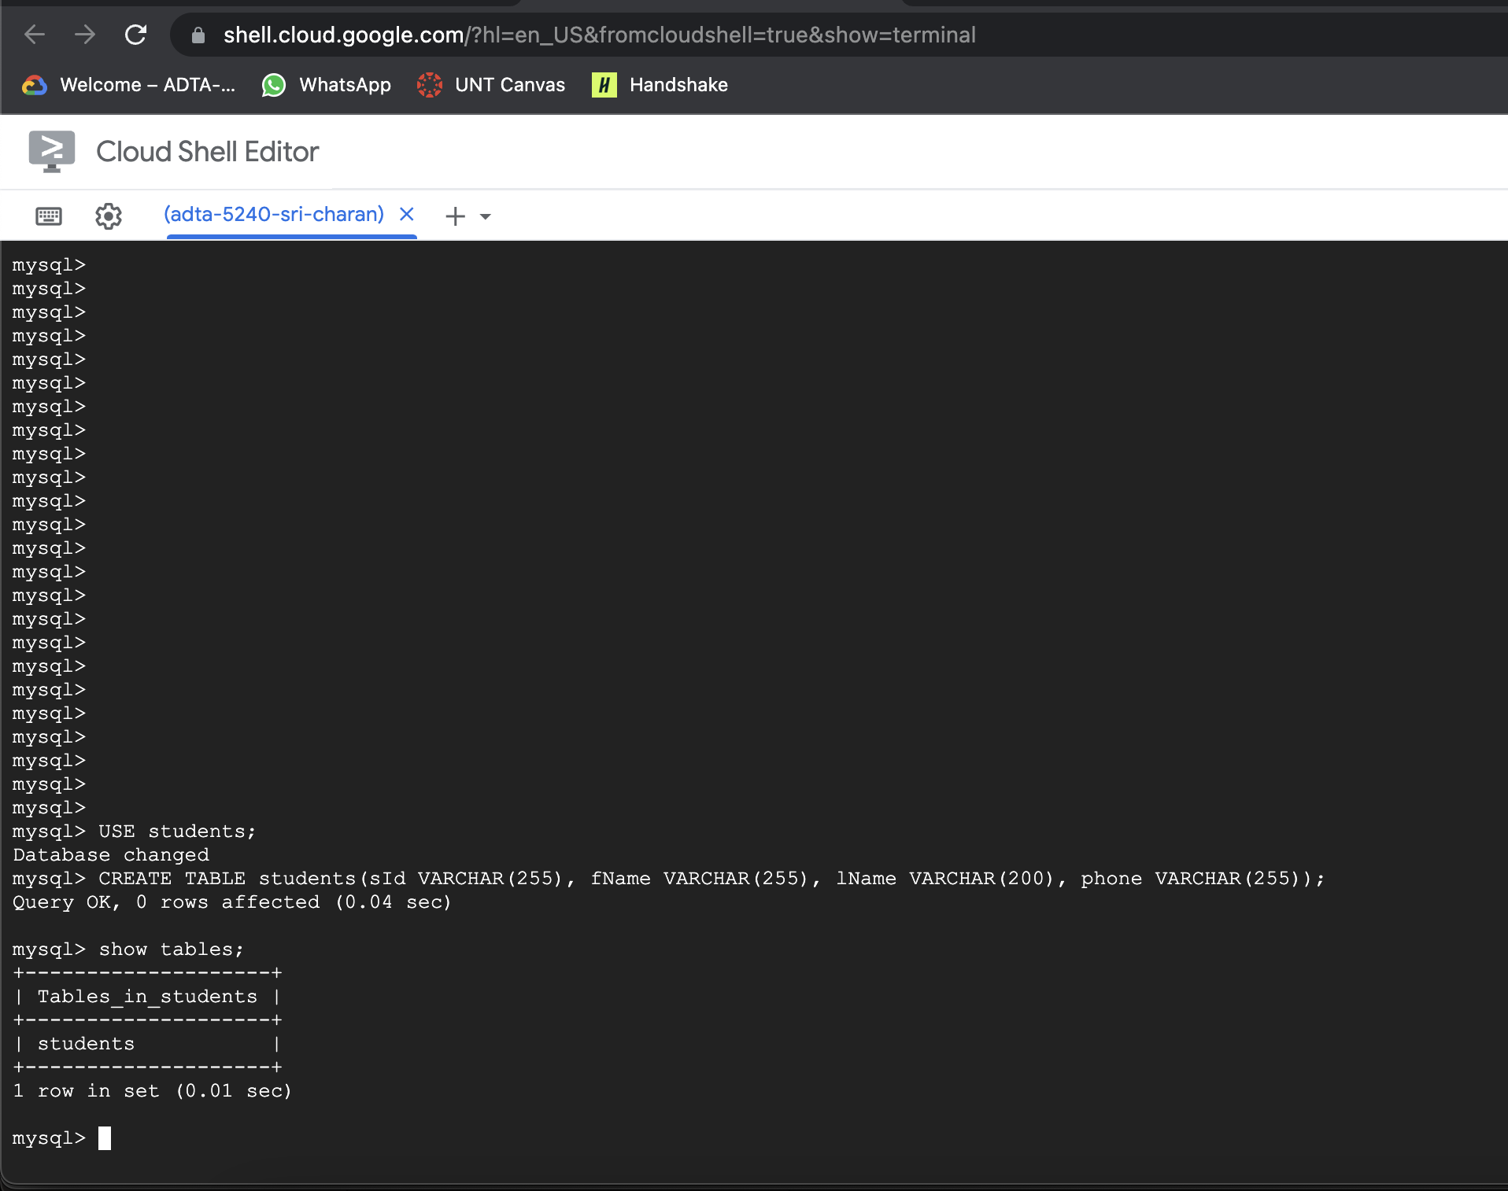

**Task 3: Insert data into table**

1. Insert some data into table by following lines of queries
2. INSERT INTO students (“sId”, “fName”, “lName”,”phone”) VALUES (‘001’, “John”, “Doe”, “1234567890”);
3. INSERT INTO students VALUES(“002”, “Joe”, “Kelly”, “1122334455”);
4. INSERT INTO students VALUES(“003, “Jack”, “Wilson”, “9876543210”);
5. INSERT INTO students VALUES(“004”, “Jonathan”, “Grisham”, “9988007766”);

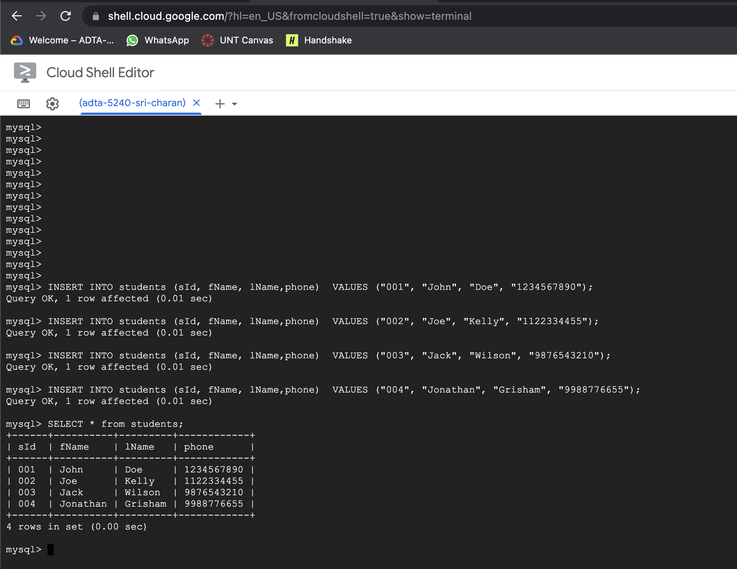

Task 4: View data that is inserted

1. You can read data inserted using "SELECT * from students;”

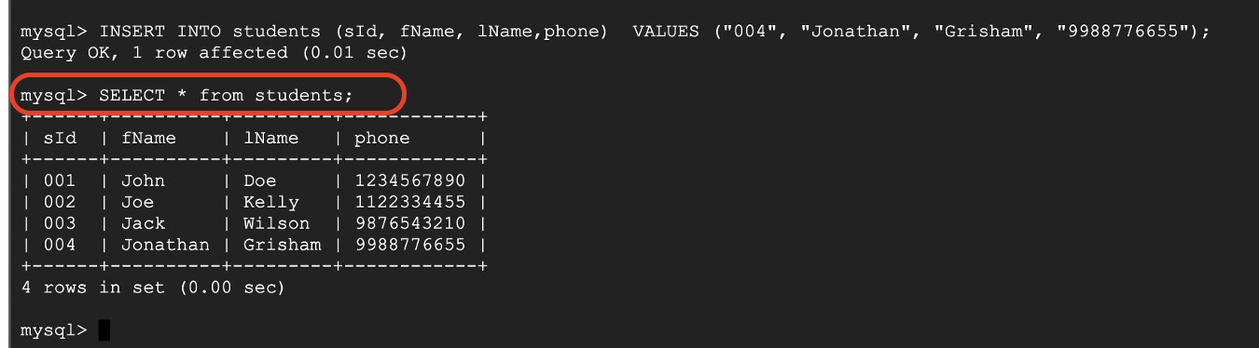

**Note:** Make sure you delete the instance after use to minimize costs. During deletion, you may face a warning about delete protection – to overcome this – while instance is running, click on edit option on top and scroll to “Customize your instance” and expand “Data Protection”. Under this, you need to uncheck “Enable Delete Protection”.

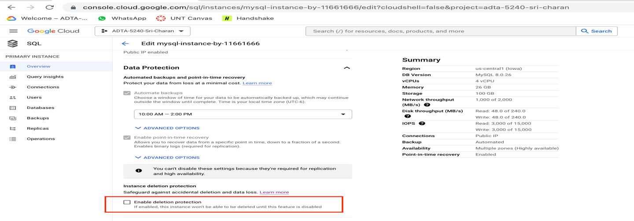

**Assignment 2: Cloud Spanner**

We first enable the Cloud Spanner API from GCP marketplace

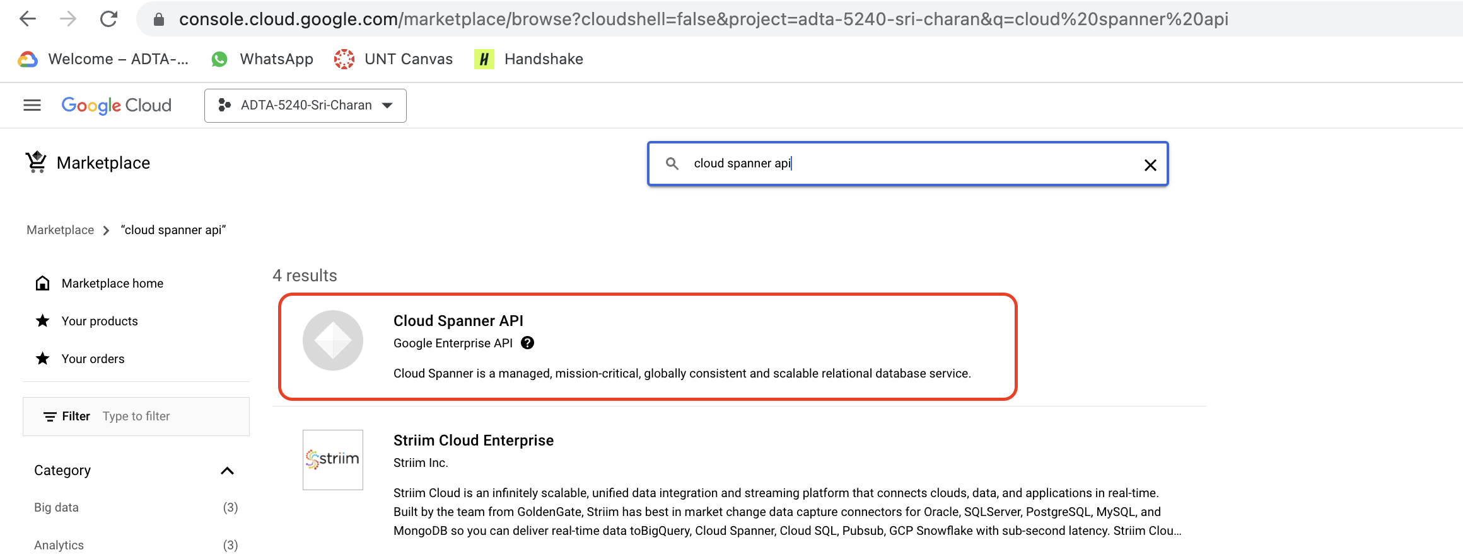

**Task 1: Create cloud spanner instance**

1. To begin with, we set default project in the cloud shell. Activate Cloud Shell by click on “Cloud Shell” icon towards top right side of screen. You can see cloud shell at bottom of screen

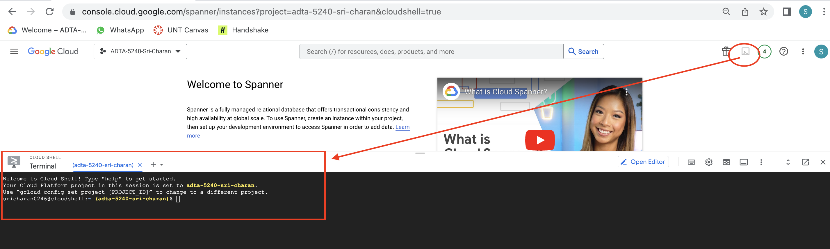

1. To set current project as default project, run below command on cloud shell

gcloud config set project adta-5240-sri-charan

A dialog window opens to Authorize access, click on “Authorize”

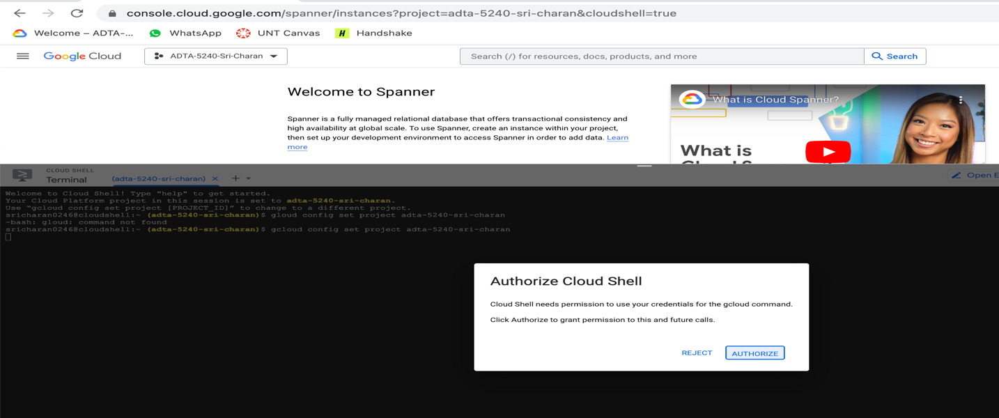

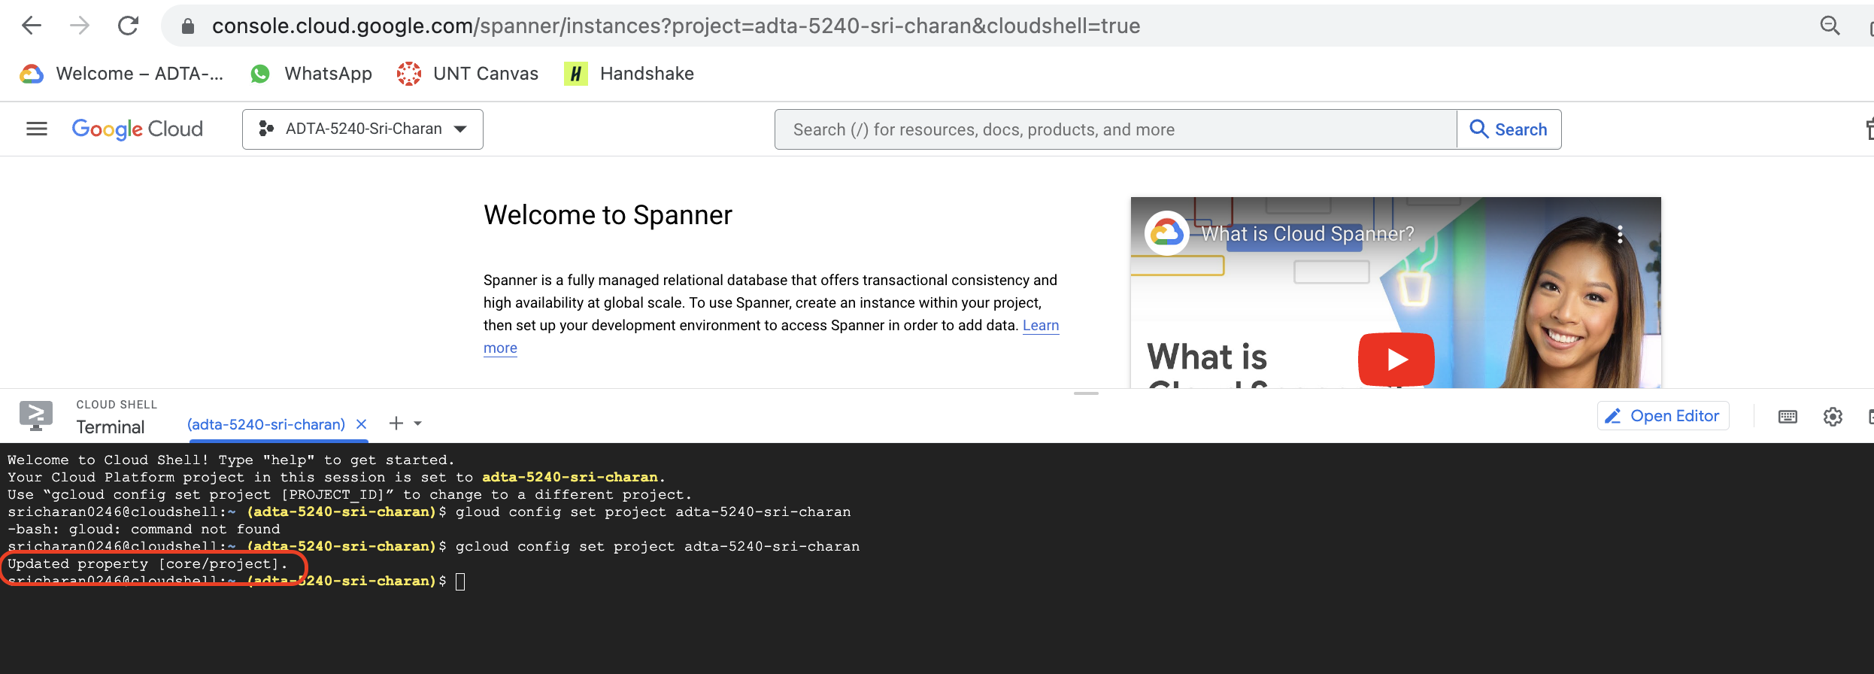

1. Now, we create cloud spanner instance for using it
   1. Before creating instance, we first start with instance configuration. Which defines geographical location and replication factor of the instance
   2. Now, set up authorization
      1. Run command: gcloud auth application-default login

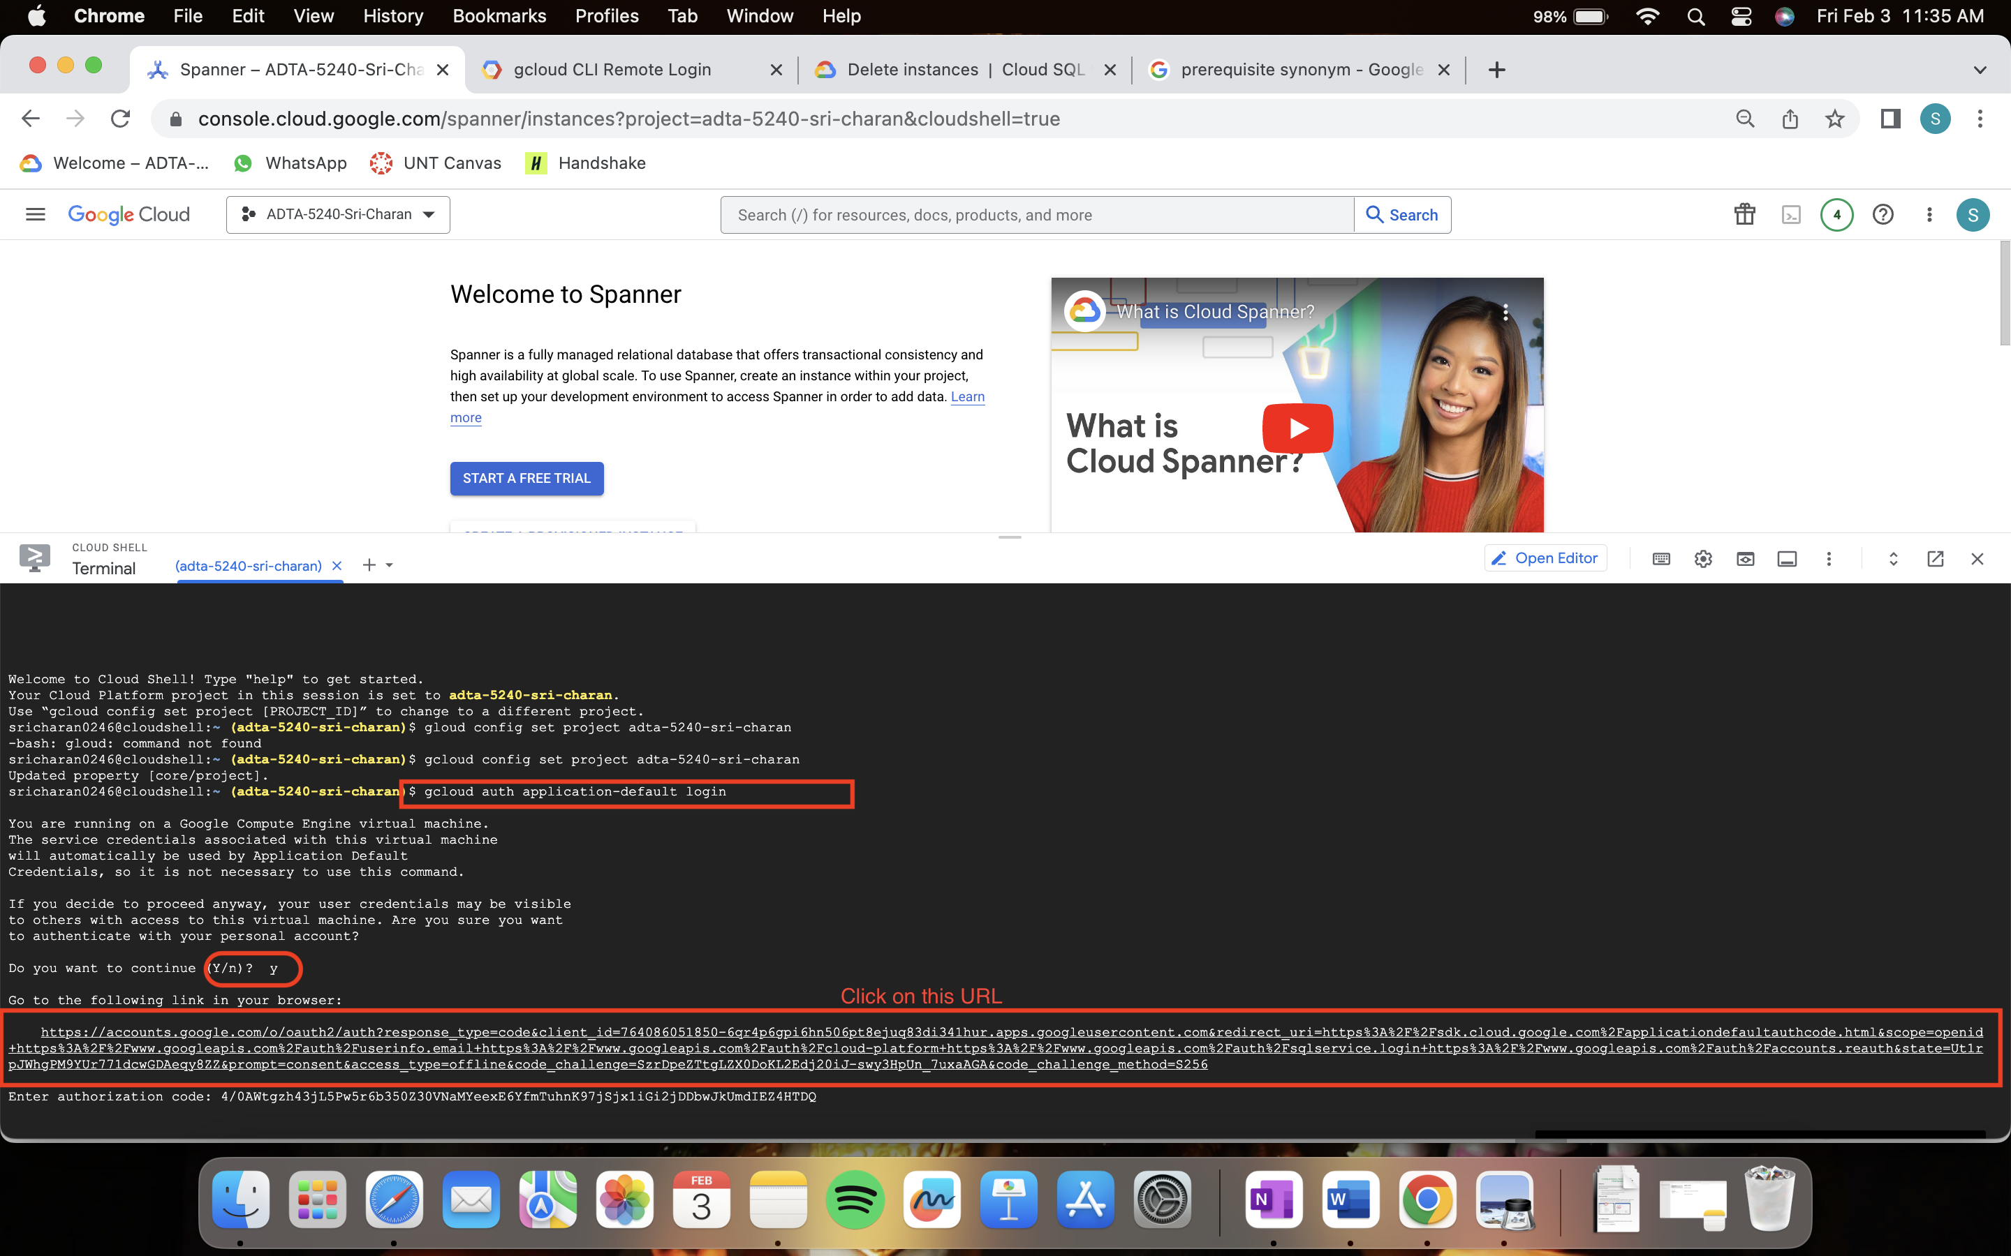

* + 1. Above URL navigates to select gmail account, select account which you use GCP and click Allow.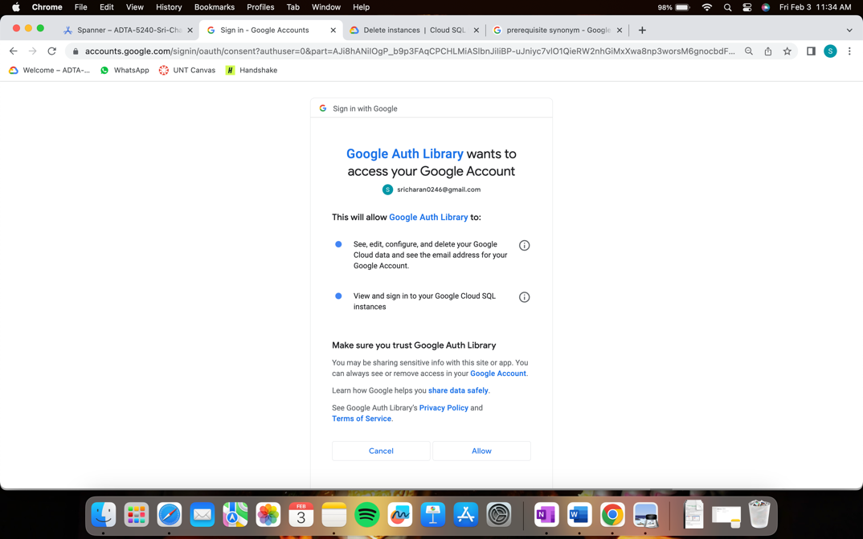
    2. Then, it shows you Authorization code. Copy it

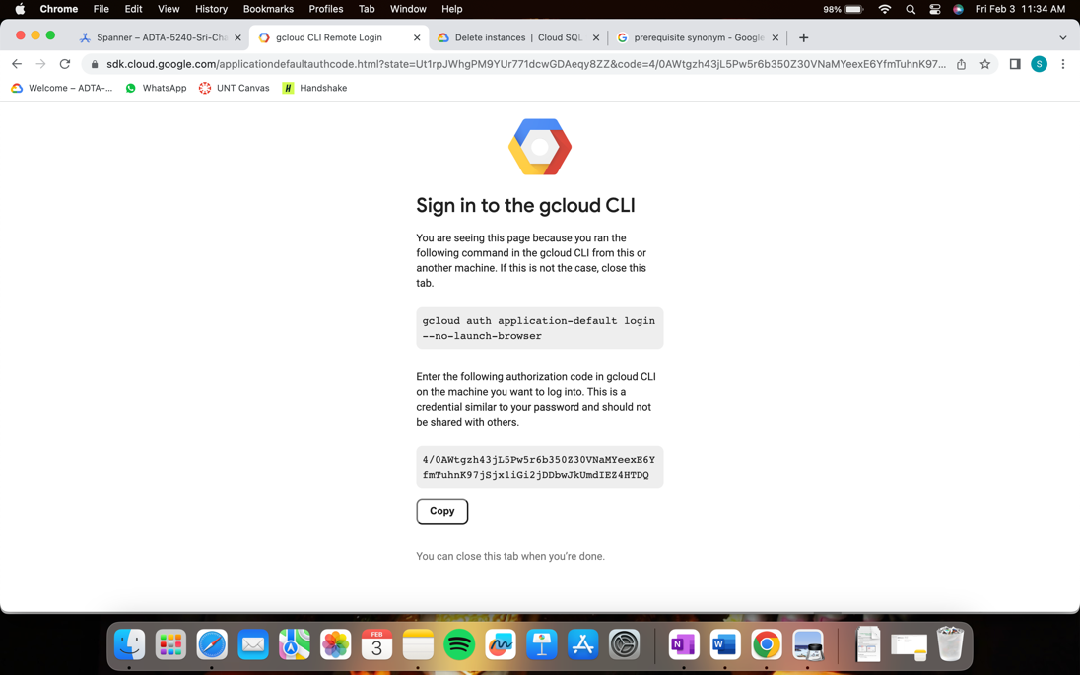

* + 1. Paste it on cloud shell

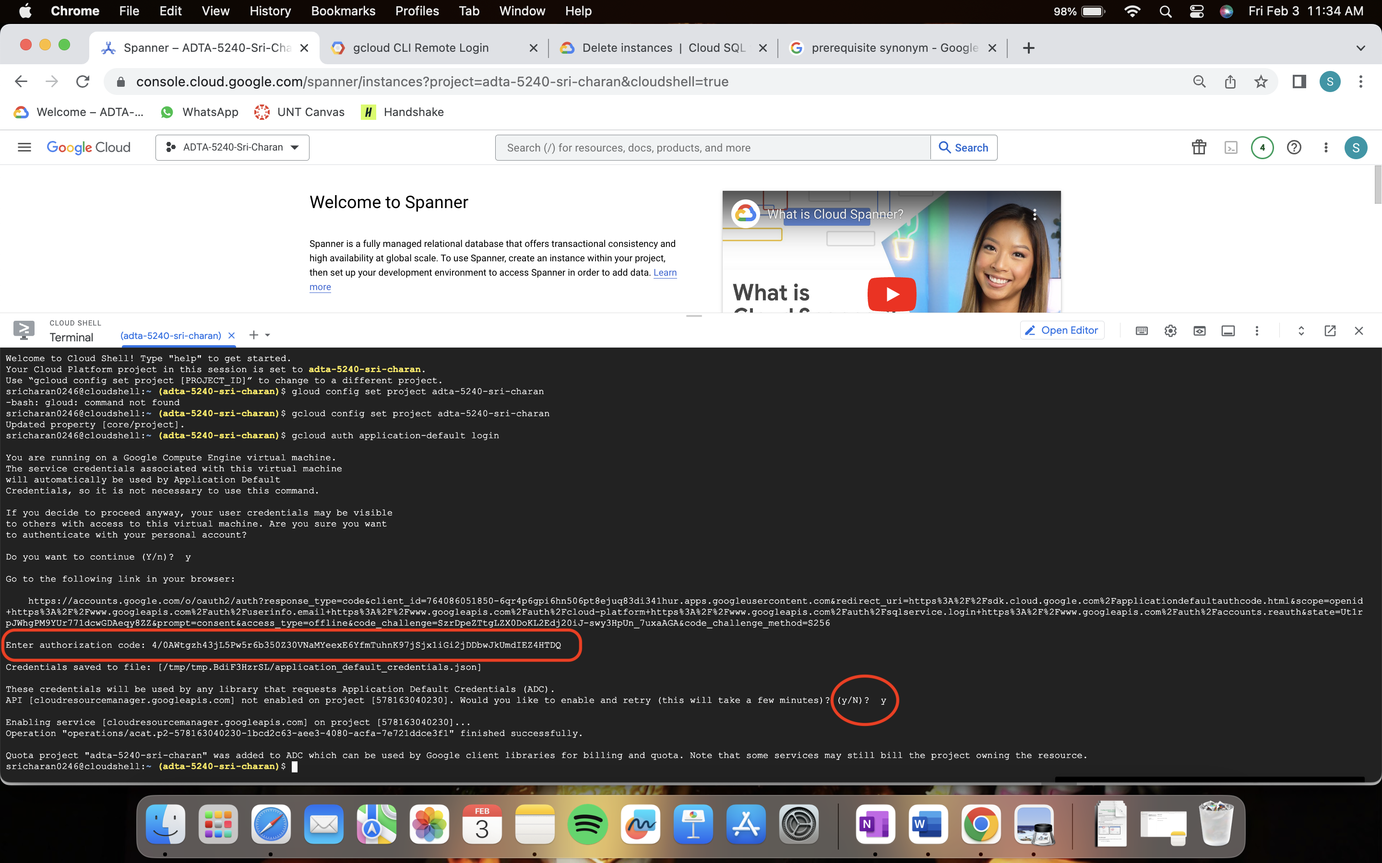

* + 1. Now, you are authenticated!
  1. Now, run below command to check instance list

gcloud spanner instance-configs list

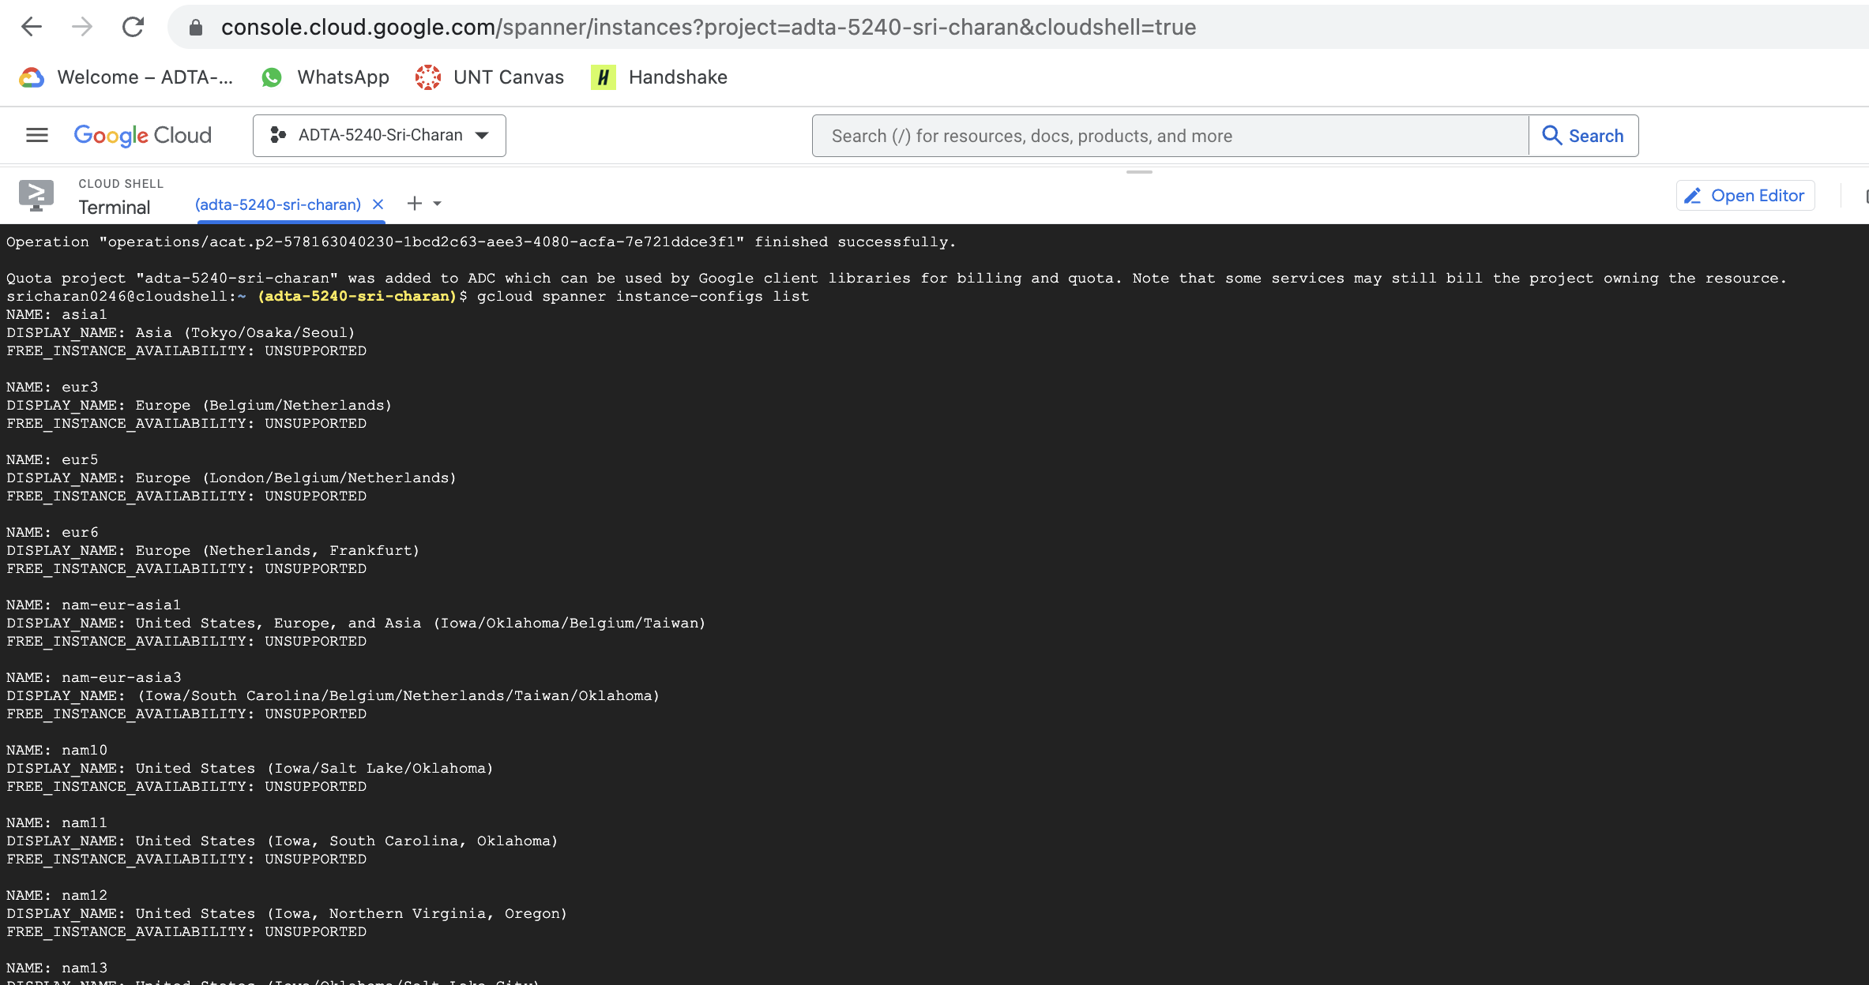

1. Now, create cloud spanner instance
   1. Run command: gcloud spanner instances create spanner-instance-11661666 --config=regional-us-central1 --description="My Instance" --nodes=1

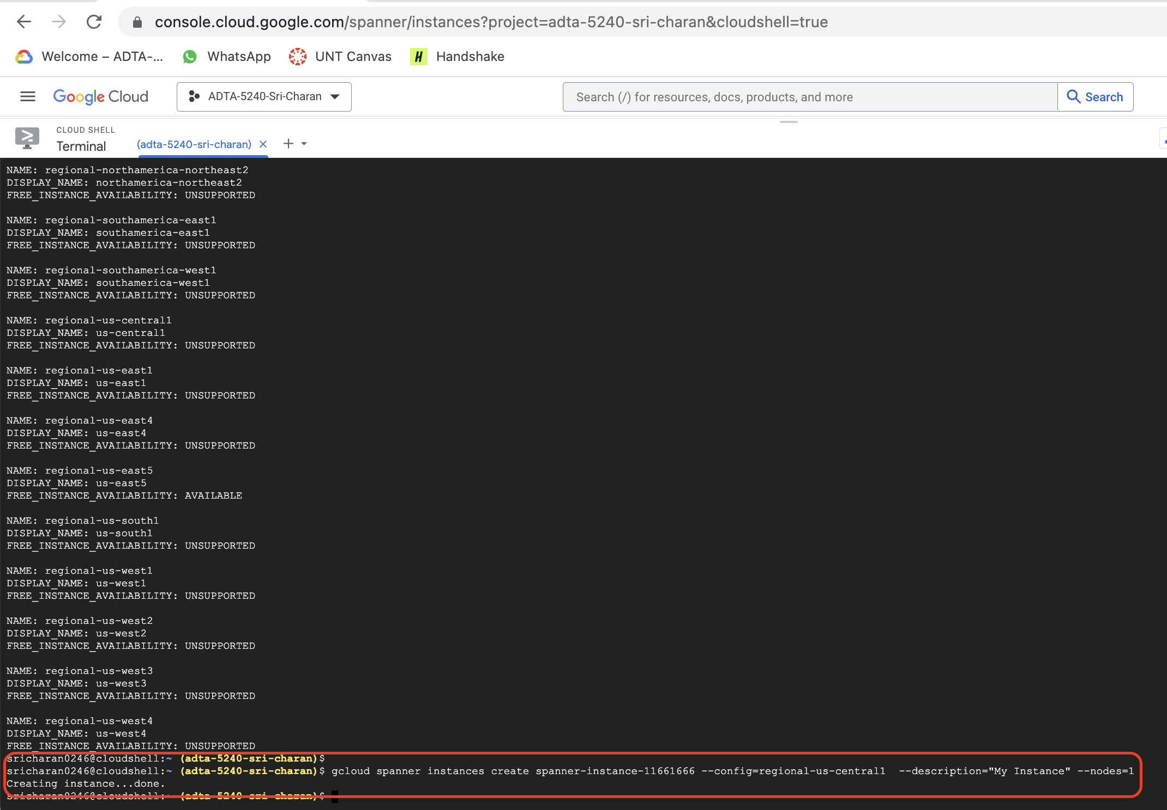

1. Now, set spanner to default
   1. Command: gcloud config set spanner/instance spanner-instance-11661666

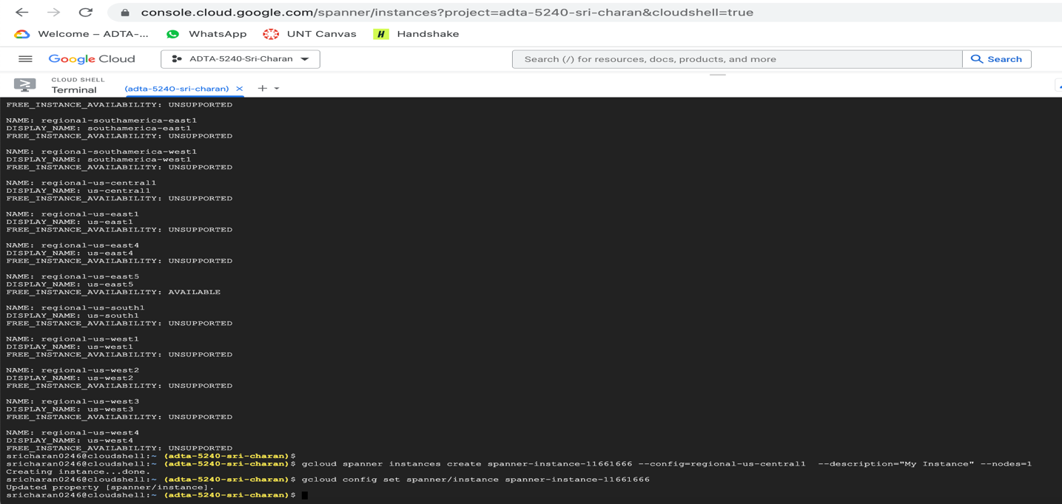

**Task 2: Create Dataset and 2 tables**

1. Create new database
   1. Command: gcloud spanner databases create students-db

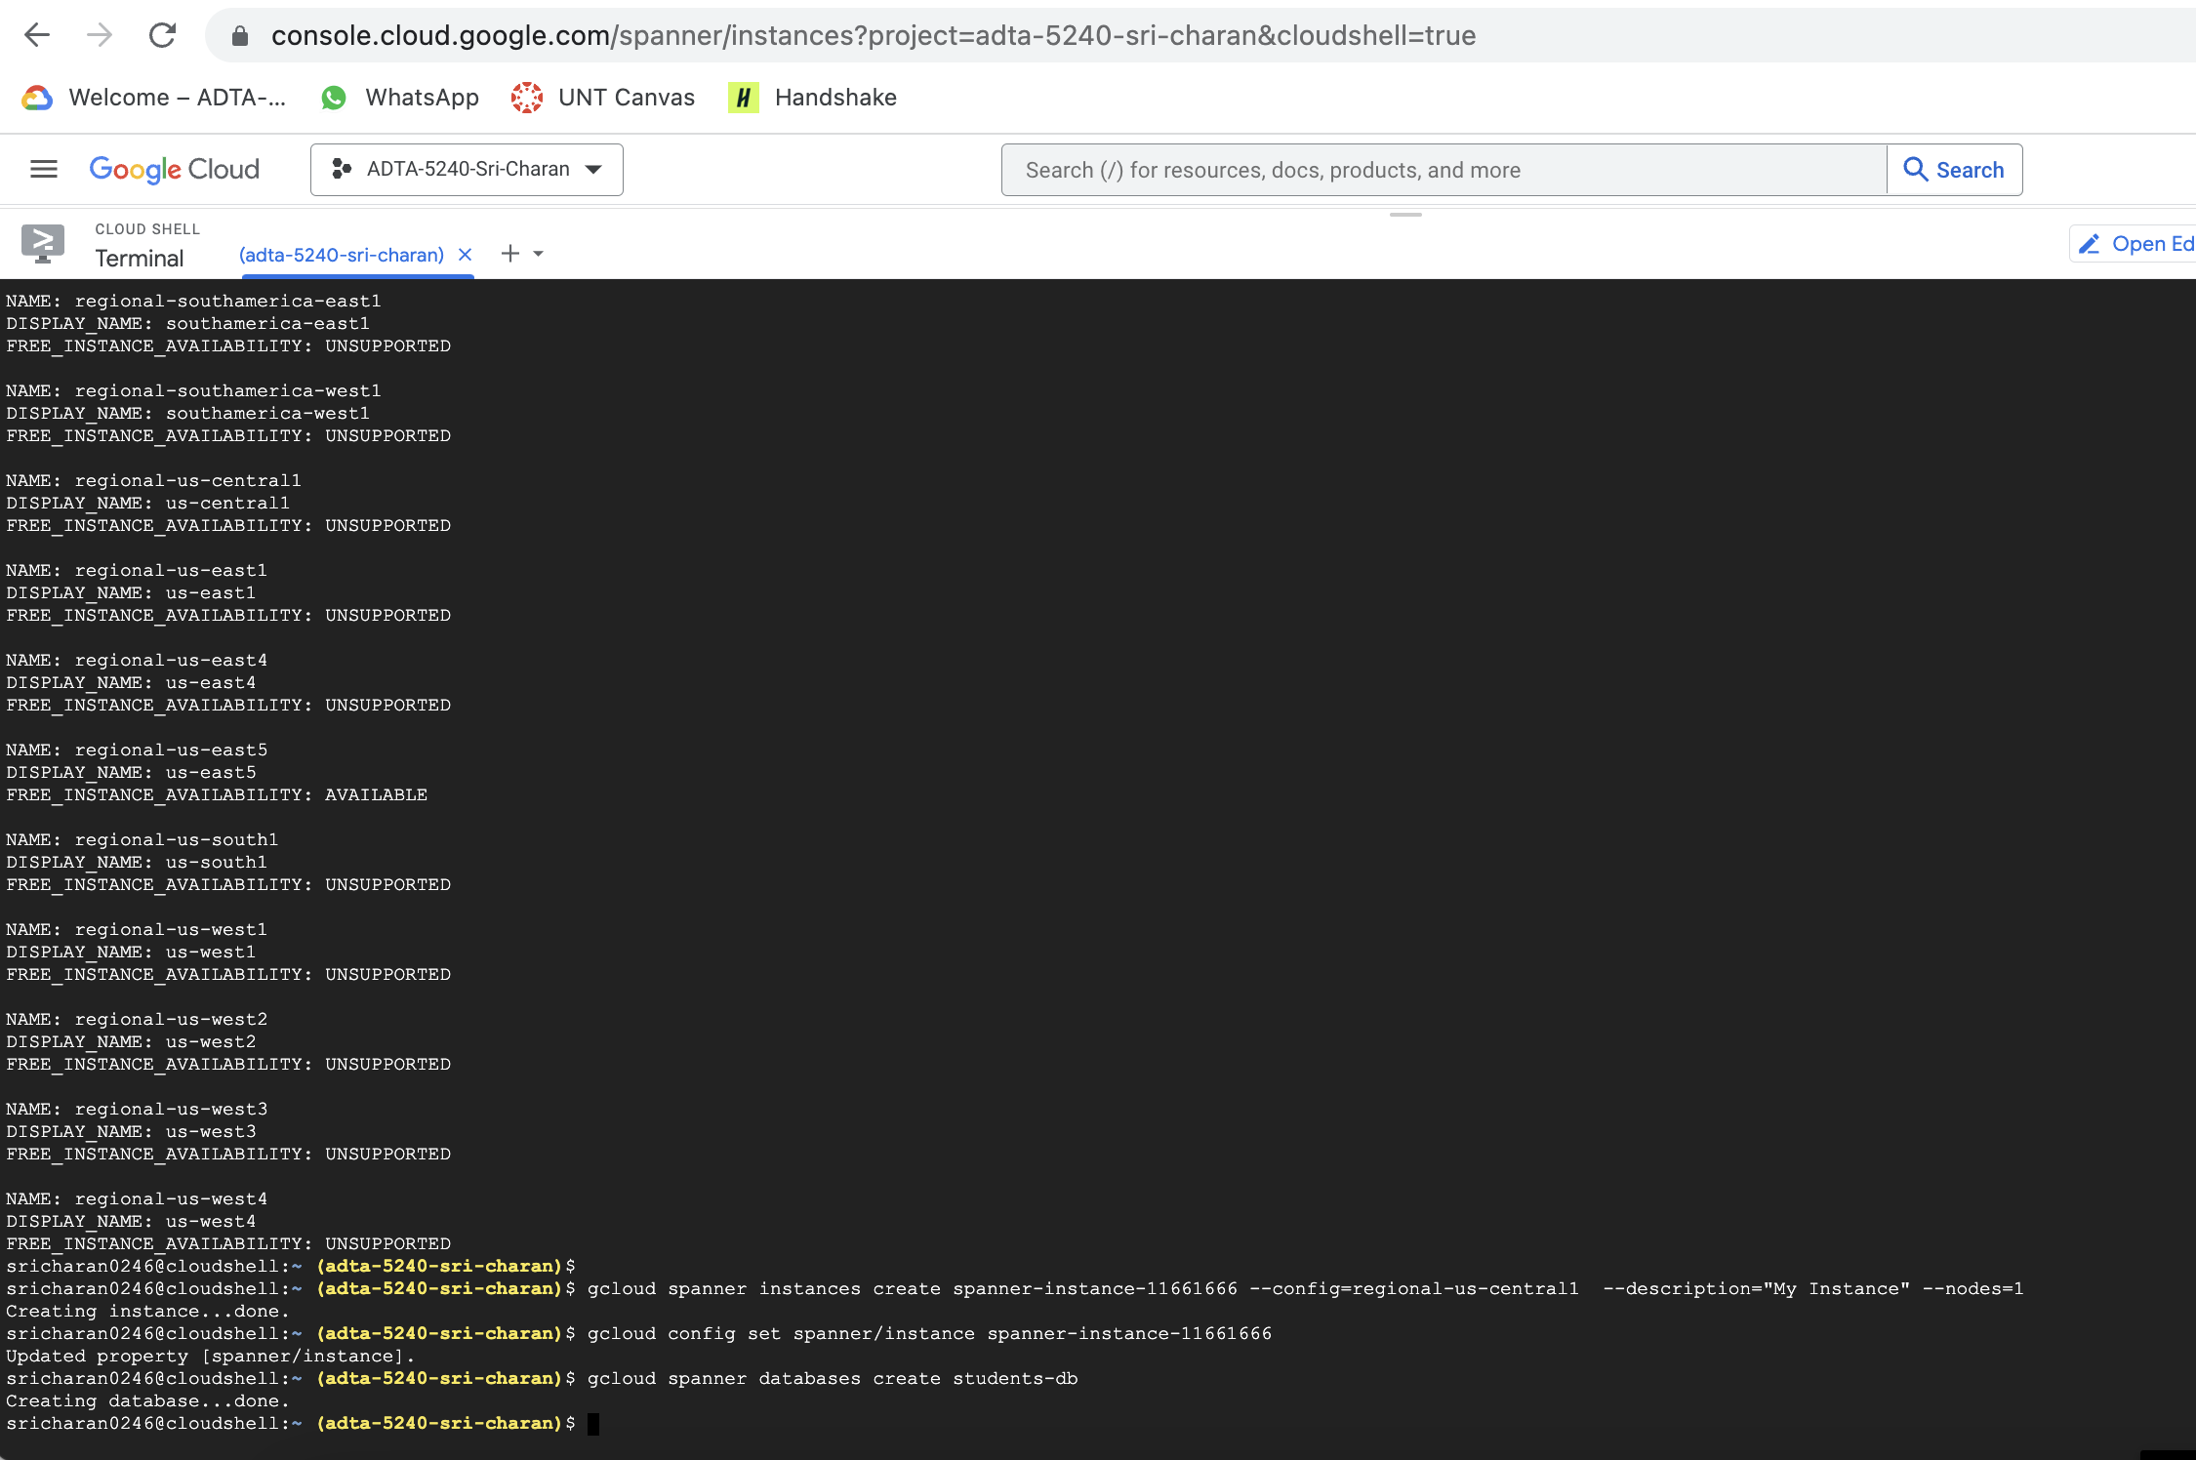

1. Now, create schema under above created database
   1. Command: gcloud spanner databases ddl update students-db --ddl='CREATE TABLE Singers ( SingerId INT64 NOT NULL, FirstName STRING(1024), LastName STRING(1024), SingerInfo BYTES(MAX) ) PRIMARY KEY (SingerId)'

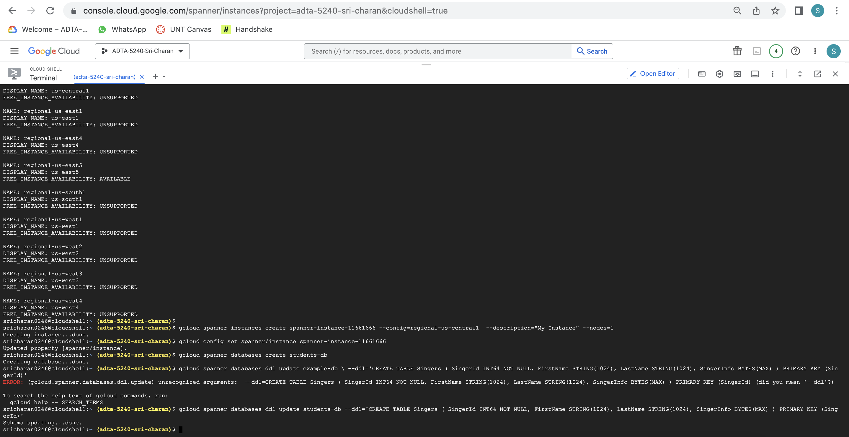

* 1. Creating Albums schema

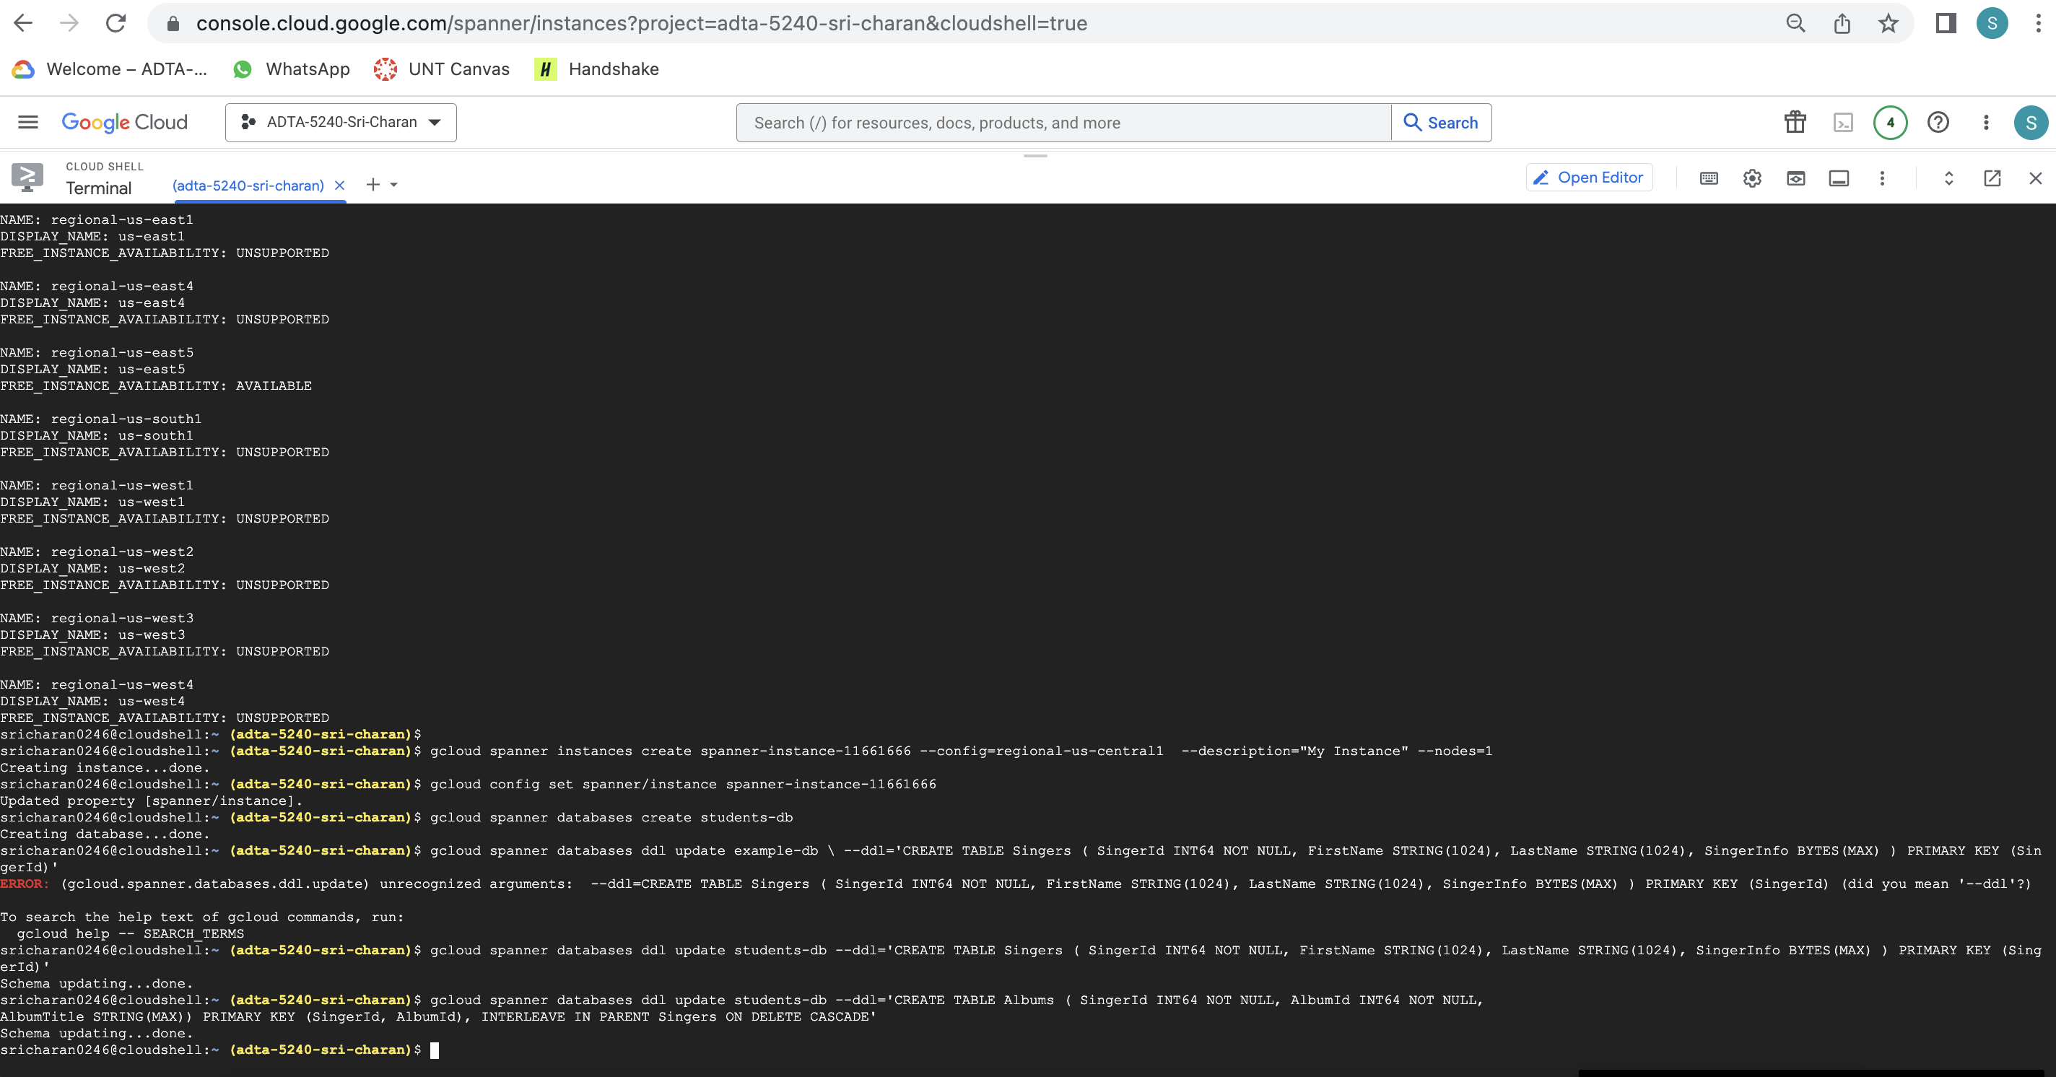

**Task 3: Insert data into above tables/schema**

1. Insert into singers table
2. Run command: gcloud spanner rows insert --database=students-db --table=Singers --data=SingerId=1,FirstName=Marc,LastName=Richards
3. gcloud spanner rows insert --database=students-db --table=Singers --data=SingerId=2,FirstName=Catalina,LastName=Smith

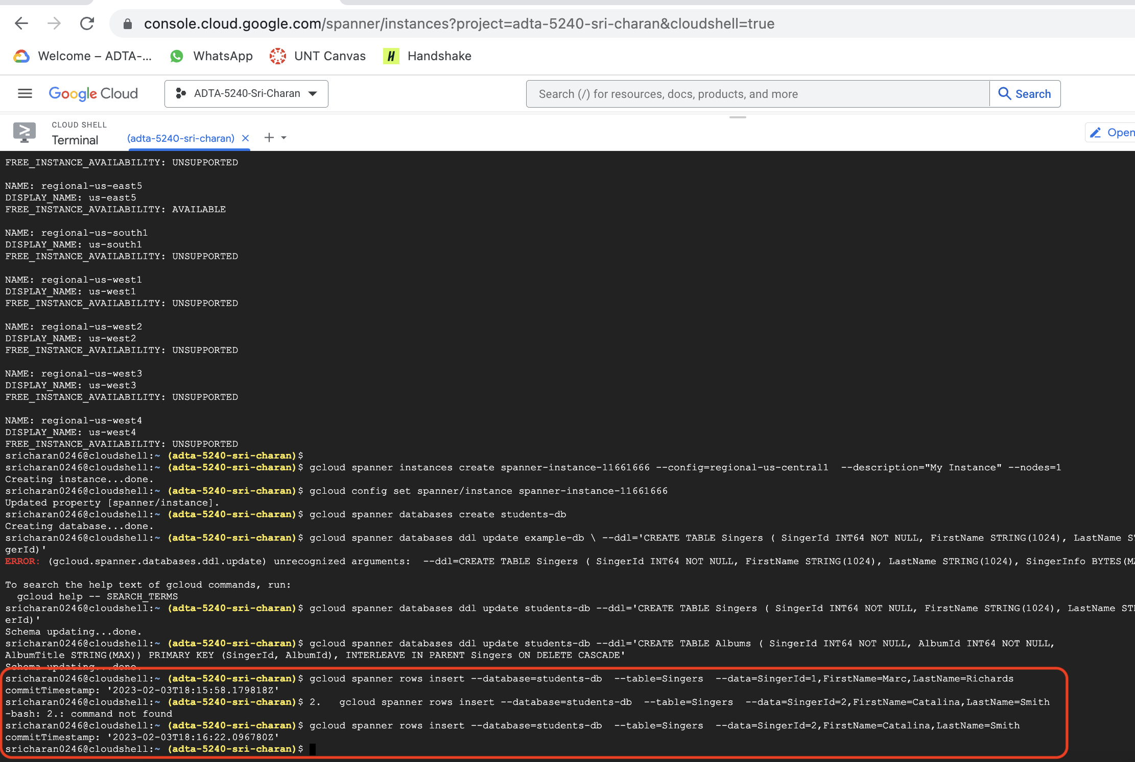

1. Insert into albums table
2. command: gcloud spanner rows insert --database=students-db --table=Albums --data=SingerId=1,AlbumId=1,AlbumTitle="Total Junk"
3. gcloud spanner rows insert --database=students-db --table=Albums --data=SingerId=2,AlbumId=1,AlbumTitle="Green"

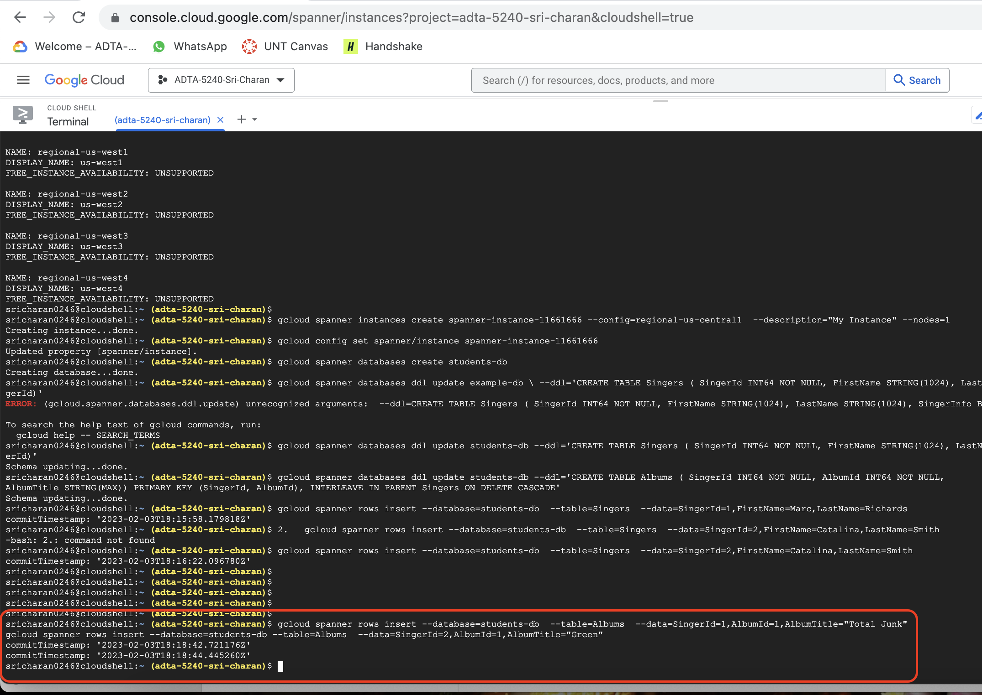

**Task 4: to view data in the tables**

1. In order to query the data, we now switch to GCP console’s cloud spanner service. We can see newly created spanner instance available.
2. Click on instance and select students-db database
3. Now, you can see 2 tables under students-db database

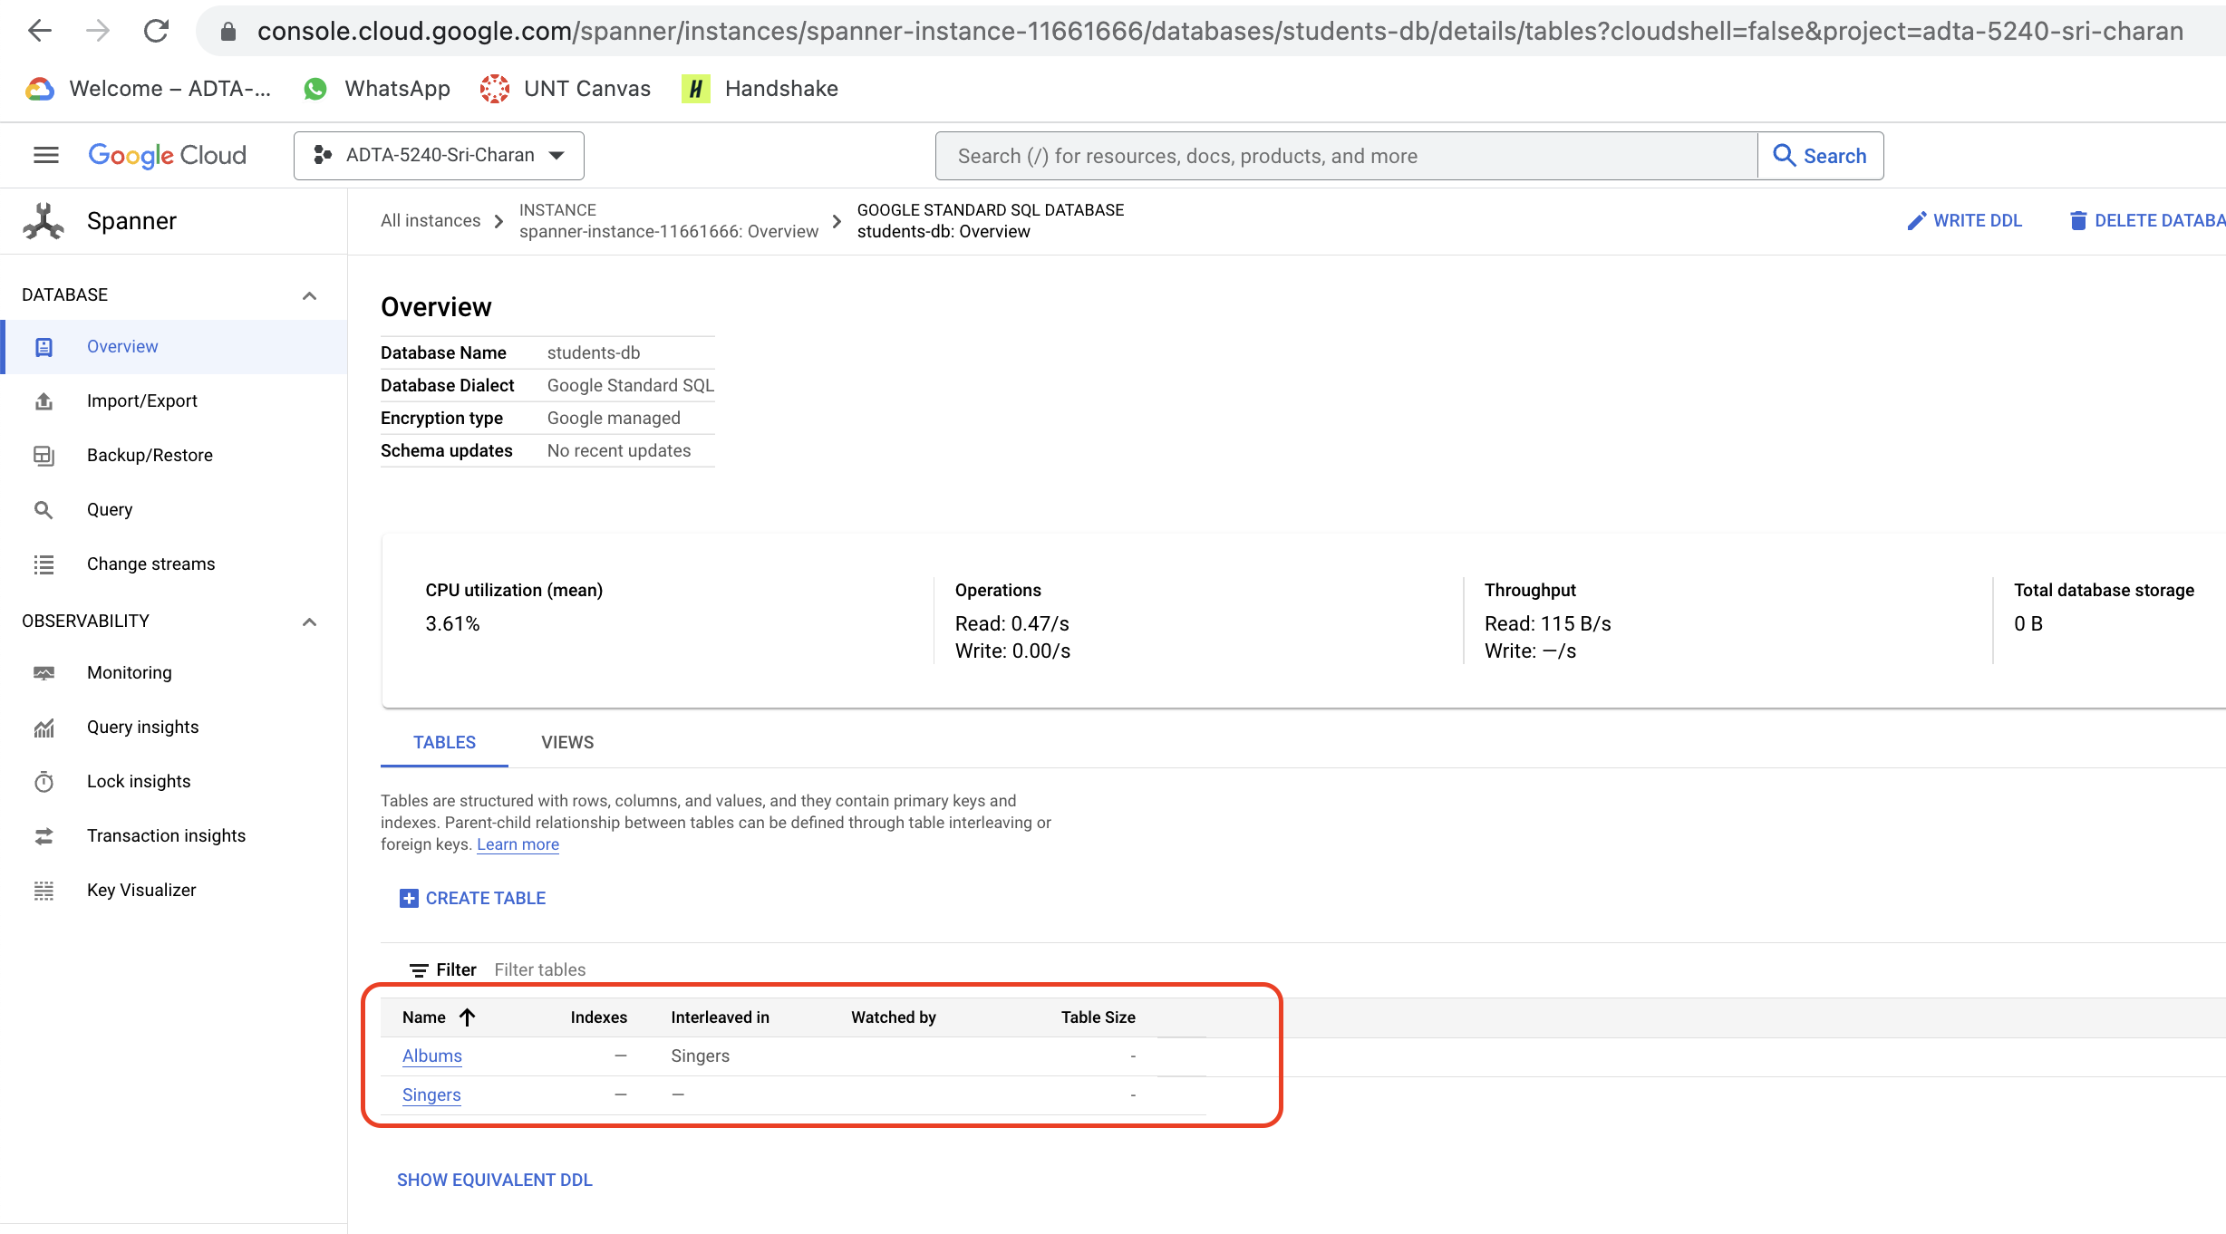

1. Select Singers database, click on query in the left pane and write query(SELECT * FROM Singers;) in the editor. When you click on “RUN SELECTED”, you get results at below

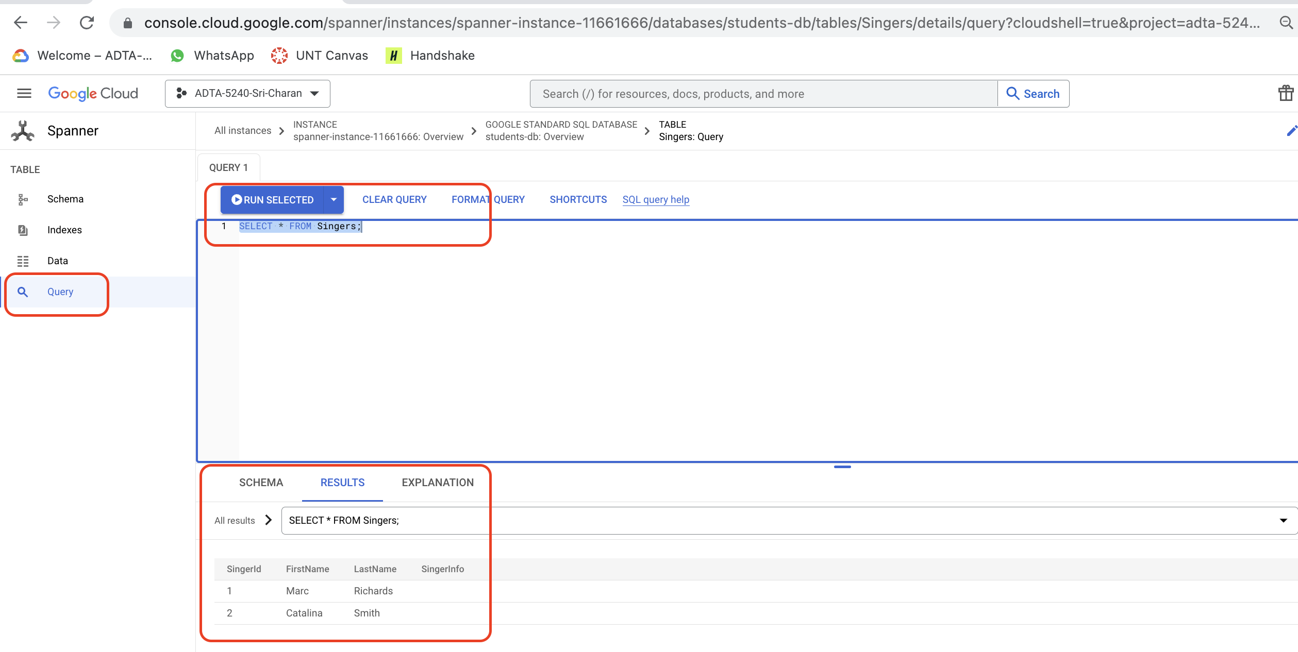

1. You can repeat above step for Albums table as well

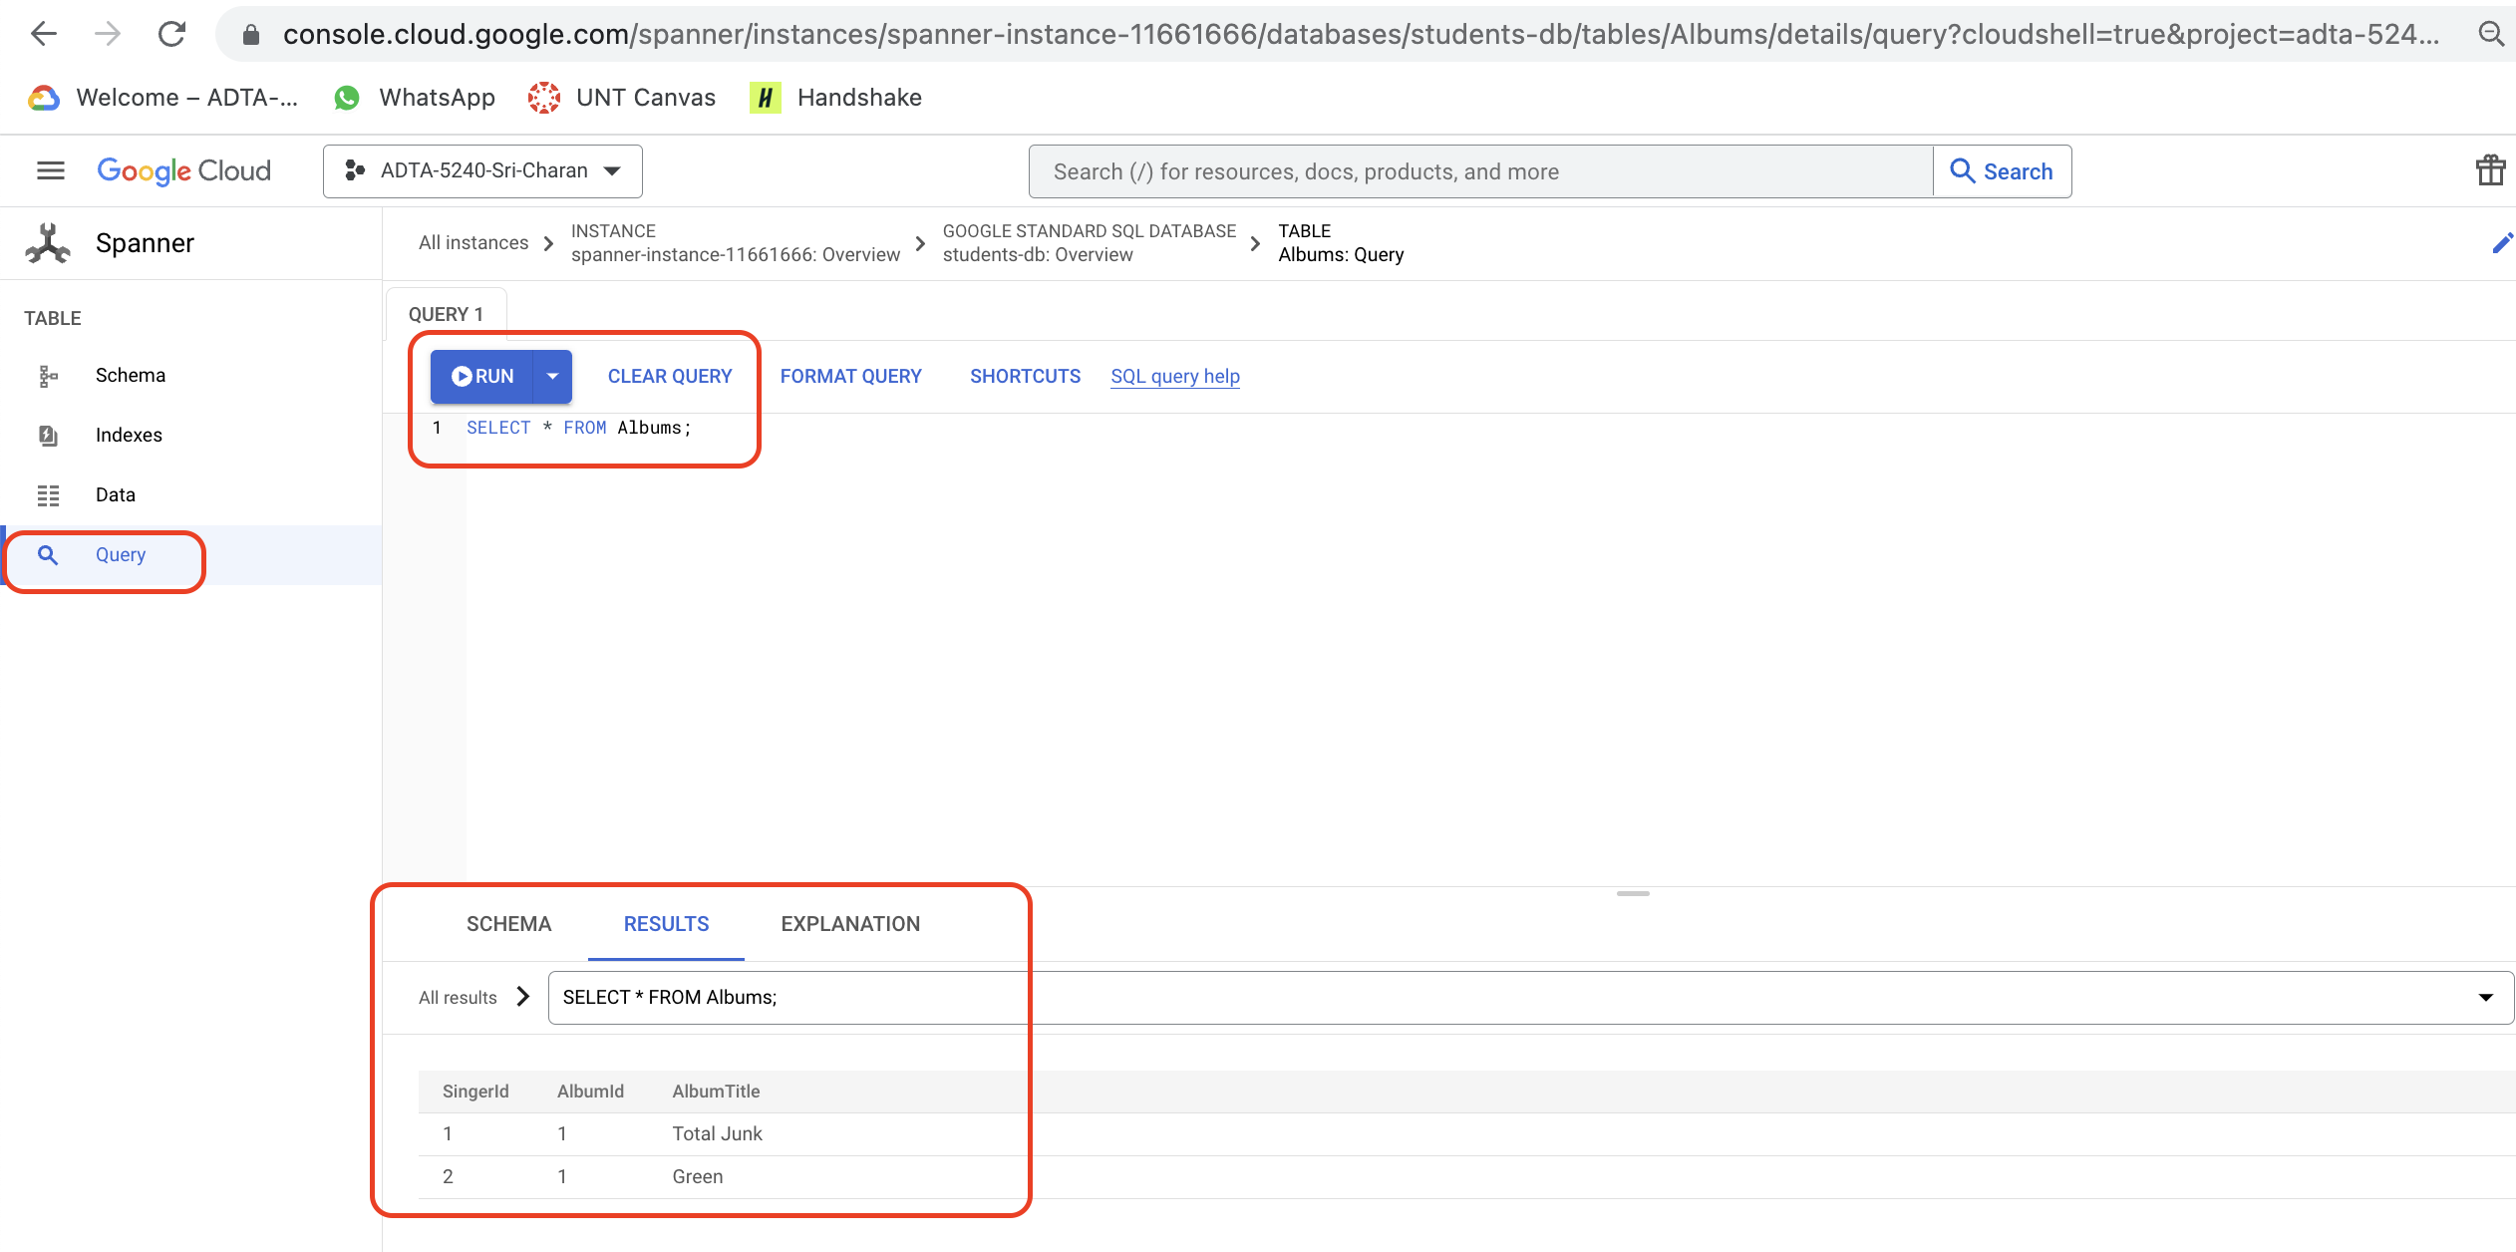

**Note:** Make sure you delete database and instance created for not getting charged more.